Date: 01/04/26
📊 Final Count:
🟢 Bullish | 82
🔴 Bearish | 104
Total | 186

🟢 BULLISH TRADES --- 82
1 | COALINDIA
2 | HINDALCO
3 | NATIONALUM
4 | ONGC
5 | SAMMAANCAP
6 | SAIL
7 | GAIL
8 | AUROPHARMA
9 | CGPOWER
10 | APLAPOLLO
11 | ADANIENSOL
12 | AMBER
13 | HCLTECH
14 | INDIGO
15 | LT
16 | MARICO
17 | MARUTI
18 | NMDC
19 | POLICYBZR
20 | SONACOMS
21 | TECHM
22 | TITAN
23 | TRENT
24 | BAJAJ-AUTO
25 | IRCTC
26 | MUTHOOTFIN
27 | JSWSTEEL
28 | TATASTEEL
29 | POLYCAB
30 | ADANIGREEN
31 | ADANIPORTS
32 | ABCAPITAL
33 | ASIANPAINT
34 | DELHIVERY
35 | HFCL
36 | INDUSTOWER
37 | INOXWIND
38 | KPITTECH
39 | KALYANKJIL
40 | LICHSGFIN
41 | LAURUSLABS
42 | MANAPPURAM
43 | NBCC
44 | NCC
45 | PAGEIND
46 | PETRONET
47 | PFC
48 | RECLTD
49 | RVNL
50 | TVSMOTOR
51 | TATATECH
52 | NAUKRI
53 | PPLPHARMA
54 | RBLBANK
55 | AUBANK
56 | AMBUJACEM
57 | BSE
58 | BOSCHLTD
59 | COFORGE
60 | CAMS
61 | INFY
62 | MAZDOCK
63 | MPHASIS
64 | OFSS
65 | PIIND
66 | PERSISTENT
67 | SUZLON
68 | TITAGARH
69 | TCS
70 | FEDERALBNK
71 | WIPRO
72 | BEL
73 | CDSL
74 | DIXON
75 | EXIDEIND
76 | GMRAIRPORT
77 | HDFCAMC
78 | HINDZINC
79 | POWERINDIA
80 | IEX
81 | SRF
82 | SOLARINDS
🔴 BEARISH TRADES --- 104
1 | CHOLAFIN
2 | DALBHARAT
3 | HDFCLIFE
4 | INDIANB
5 | IOC
6 | JUBLFOOD
7 | LTF
8 | NTPC
9 | SBICARD
10 | TATACONSUM
11 | UNIONBANK
12 | BHEL
13 | BHARTIARTL
14 | BIOCON
15 | DRREDDY
16 | GRASIM
17 | JIOFIN
18 | KOTAKBANK
19 | MFSL
20 | SUNPHARMA
21 | TMPV
22 | 360ONE
23 | ABB
24 | AUBANK
25 | ABCAPITAL
26 | BAJAJFINSV
27 | BANKBARODA
28 | BANKINDIA
29 | BLUESTARCO
30 | CANBK
31 | CYIENT
32 | DABUR
33 | HAVELLS
34 | HEROMOTOCO
35 | ICICIBANK
36 | ICICIGI
37 | ICICIPRULI
38 | IGL
39 | JSWENERGY
40 | KFINTECH
41 | LICI
42 | NESTLEIND
43 | PFC
44 | SBILIFE
45 | MOTHERSON
46 | SBIN
47 | TORNTPOWER
48 | UNOMINDA
49 | ULTRACEMCO
50 | VOLTAS
51 | ASHOKLEY
52 | AXISBANK
53 | BANDHANBNK
54 | BRITANNIA
55 | COLPAL
56 | CROMPTON
57 | DIXON
58 | EICHERMOT
59 | EXIDEIND
60 | FORTIS
61 | GODREJCP
62 | HDFCBANK
63 | HAL
64 | HINDUNILVR
65 | HUDCO
66 | IDFCFIRSTB
67 | IIFL
68 | ITC
69 | IEX
70 | IRFC
71 | LTM
72 | LODHA
73 | PAYTM
74 | PGEL
75 | PIIND
76 | PATANJALI
77 | PIDILITIND
78 | PRESTIGE
79 | PNB
80 | RECLTD
81 | RVNL
82 | RELIANCE
83 | SHREECEM
84 | SHRIRAMFIN
85 | SIEMENS
86 | TATAPOWER
87 | TATATECH
88 | INDHOTEL
89 | UPL
90 | IDEA
91 | DLF
92 | HDFCAMC
93 | IREDA
94 | INDUSINDBK
95 | OBEROIRLTY
96 | YESBANK
97 | SYNGENE
98 | NHPC
99 | BAJFINANCE
100 | NUVAMA
101 | MANKIND
102 | UNITDSPR
103 | APOLLOHOSP
104 | SUPREMEIND

Trade Taken
🟢 BULLISH SIGNAL --- ONGC

Nifty Bias : 🟢 LONG — Aligned ✅
Crossover : 2026-03-25 10:30 (7 days ago)
Pullback : 2026-03-30 15:00
Low ₹283.9 ≤ EMA9(Low) ₹284.49
High ₹285.4 (breakout level)
Confirm : 2026-04-01 09:15 (+2 candle)
Close ₹287 > Pullback High ₹285.4 (body breakout)
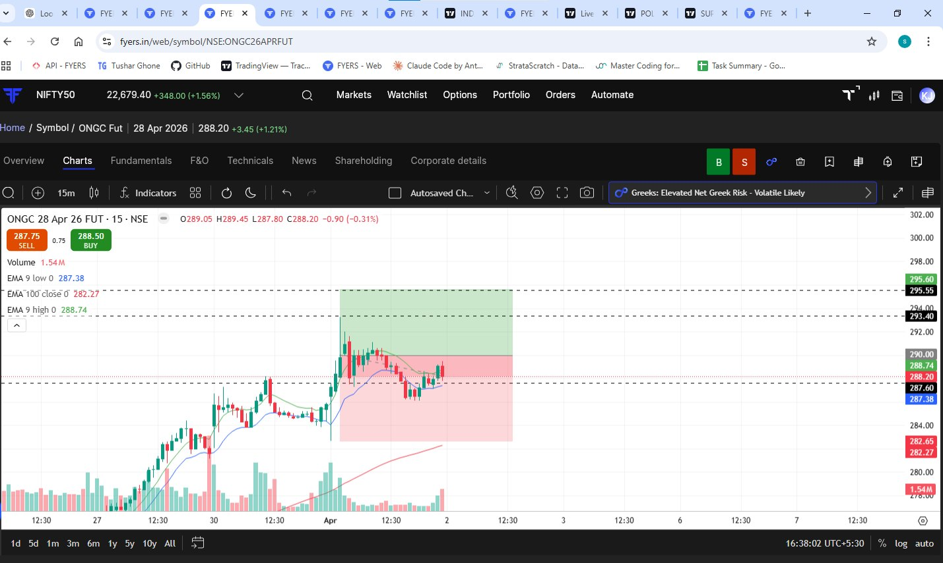
🔴 BEARISH SIGNAL --- HDFCLIFE

Nifty Bias : 🟢 LONG — Counter Trend ⚠️
Crossover : 2026-03-30 09:30 (2 days ago)
Pullback : 2026-04-01 09:15
High ₹606.15 ≥ EMA9(High) ₹596.61
Low ₹592.45 (breakdown level)
Confirm : 2026-04-01 09:30 (+1 candle)
Close ₹590.2 < Pullback Low ₹592.45 (body breakdown)
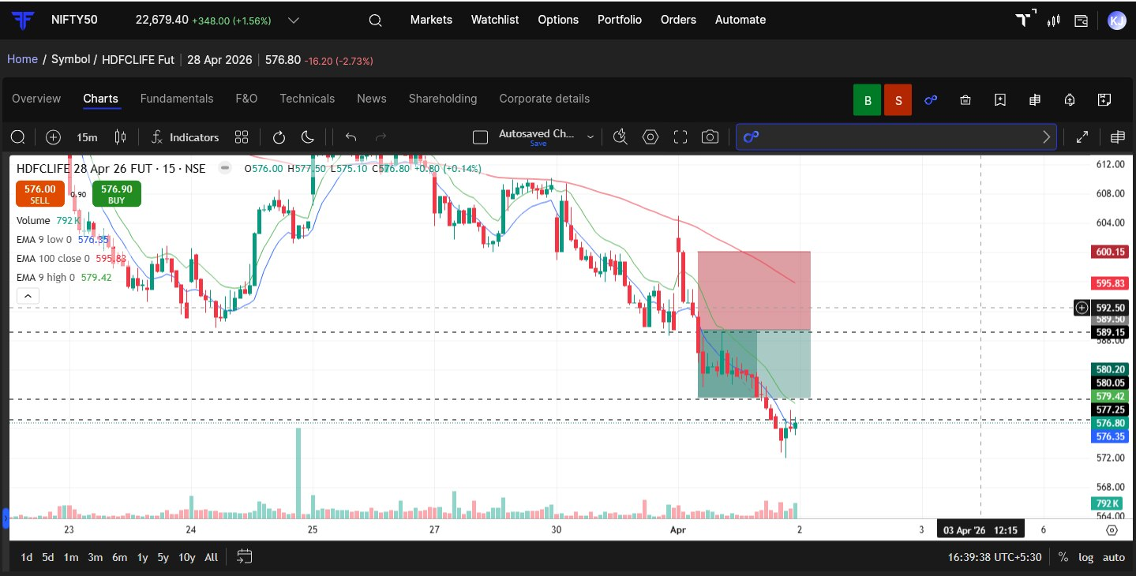
🟢 BULLISH SIGNAL --- LT

Nifty Bias : 🟢 LONG — Aligned ✅
Crossover : 2026-04-01 09:30 (3 hours ago)
Pullback : 2026-04-01 11:45
Low ₹3597.3 ≤ EMA9(Low) ₹3600.18
High ₹3616.7 (breakout level)
Confirm : 2026-04-01 12:00 (+1 candle)
Close ₹3659.2 > Pullback High ₹3616.7 (body breakout)
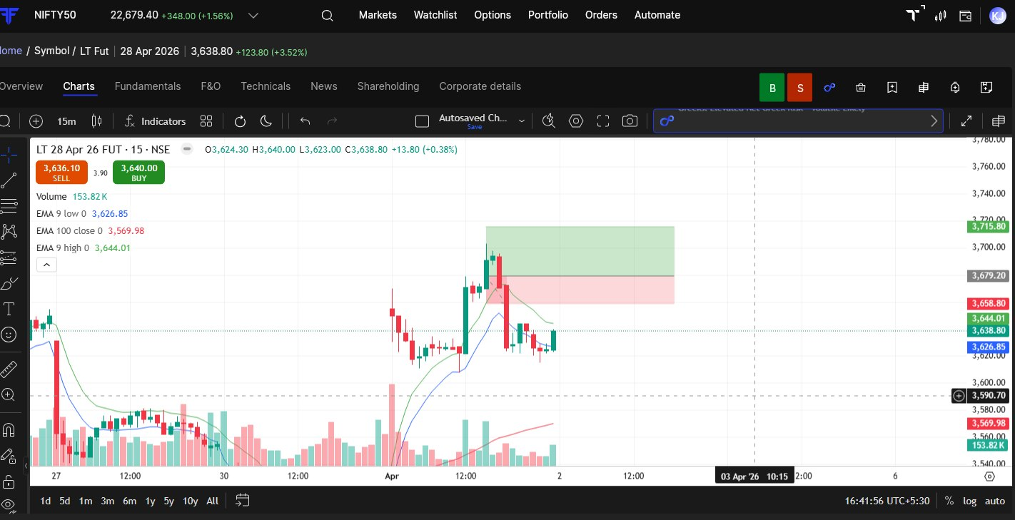

Trade Not Taken
🟢 BULLISH SIGNAL --- COALINDIA

Nifty Bias : 🟢 LONG — Aligned ✅
Crossover : 2026-03-30 09:45 (2 days ago)
Pullback : 2026-03-30 14:45
Low ₹452.8 ≤ EMA9(Low) ₹454.46
High ₹454.2 (breakout level)
Confirm : 2026-04-01 09:15 (+3 candle)
Close ₹459.7 > Pullback High ₹454.2 (body breakout)
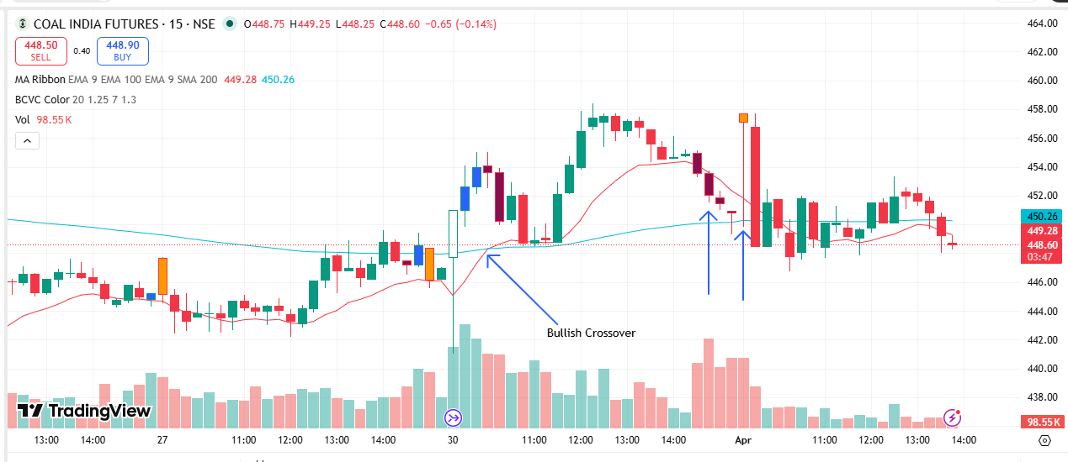
🟢 BULLISH SIGNAL --- HINDALCO

Nifty Bias : 🟢 LONG — Aligned ✅
Crossover : 2026-03-30 09:30 (2 days ago)
Pullback : 2026-03-30 15:15
Low ₹882.35 ≤ EMA9(Low) ₹884.81
High ₹888 (breakout level)
Confirm : 2026-04-01 09:15 (+1 candle)
Close ₹910.5 > Pullback High ₹888 (body breakout)
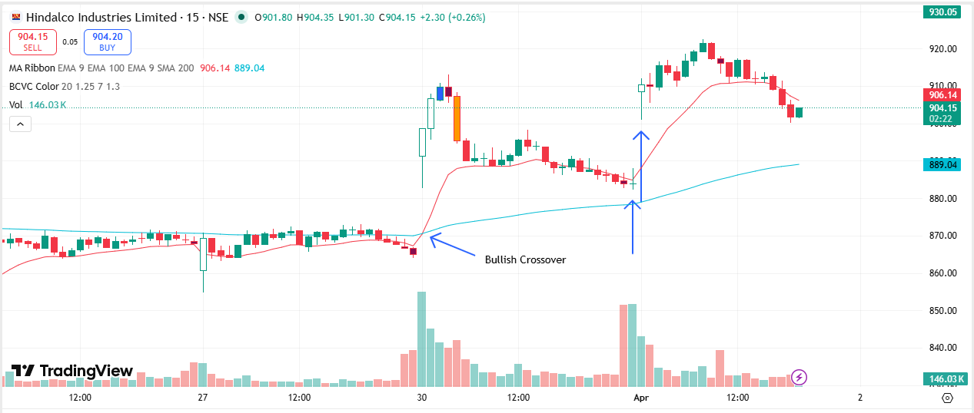
🟢 BULLISH SIGNAL --- NATIONALUM

Nifty Bias : 🟢 LONG — Aligned ✅
Crossover : 2026-03-25 11:45 (7 days ago)
Pullback : 2026-03-30 14:45
Low ₹387.25 ≤ EMA9(Low) ₹387.8
High ₹389 (breakout level)
Confirm : 2026-04-01 09:15 (+3 candle)
Close ₹401.9 > Pullback High ₹389 (body breakout)
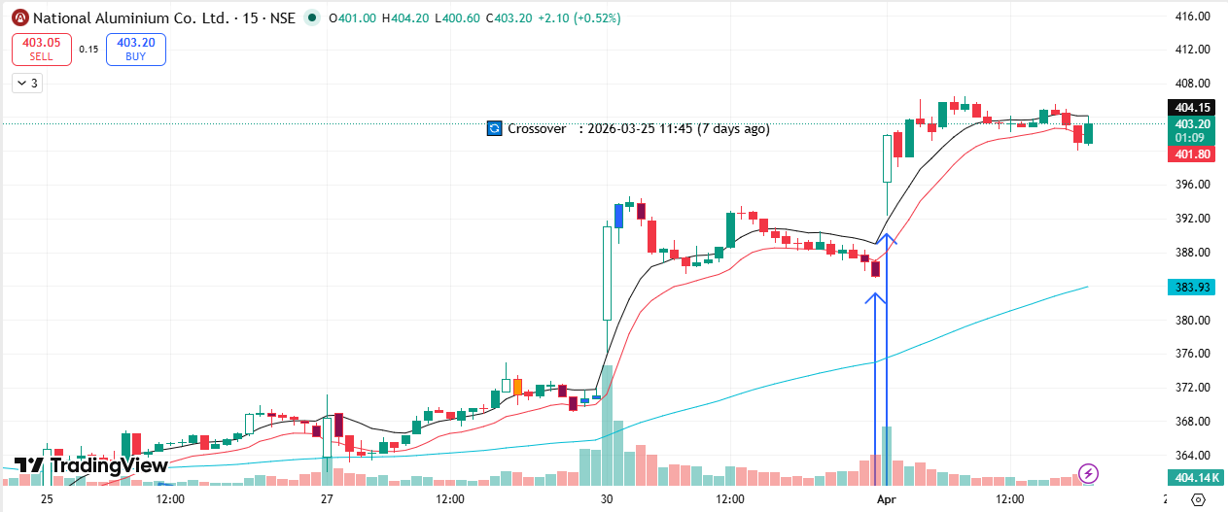
🟢 BULLISH SIGNAL --- SAMMAANCAP

Nifty Bias : 🟢 LONG — Aligned ✅
Crossover : 2026-03-24 13:45 (8 days ago)
Pullback : 2026-03-30 15:00
Low ₹149 ≤ EMA9(Low) ₹149.23
High ₹150.45 (breakout level)
Confirm : 2026-04-01 09:15 (+2 candle)
Close ₹154 > Pullback High ₹150.45 (body breakout)
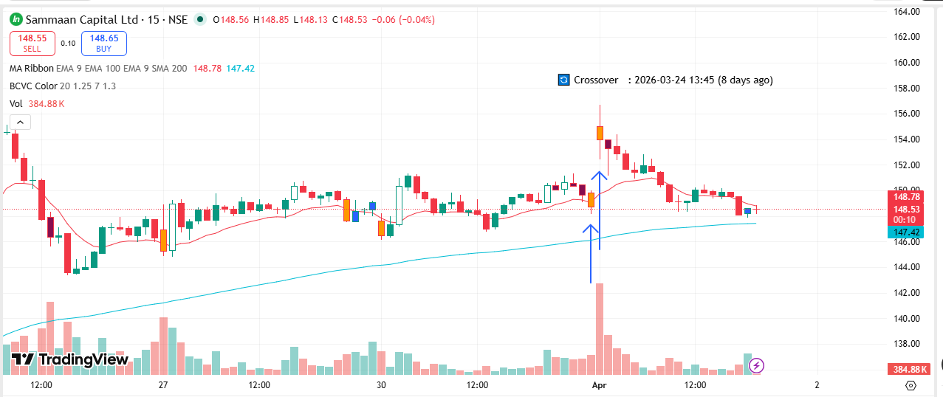
🟢 BULLISH SIGNAL --- SAIL

Nifty Bias : 🟢 LONG — Aligned ✅
Crossover : 2026-03-30 10:45 (2 days ago)
Pullback : 2026-03-30 14:45
Low ₹151.04 ≤ EMA9(Low) ₹152.28
High ₹151.95 (breakout level)
Confirm : 2026-04-01 09:15 (+3 candle)
Close ₹154.85 > Pullback High ₹151.95 (body breakout)
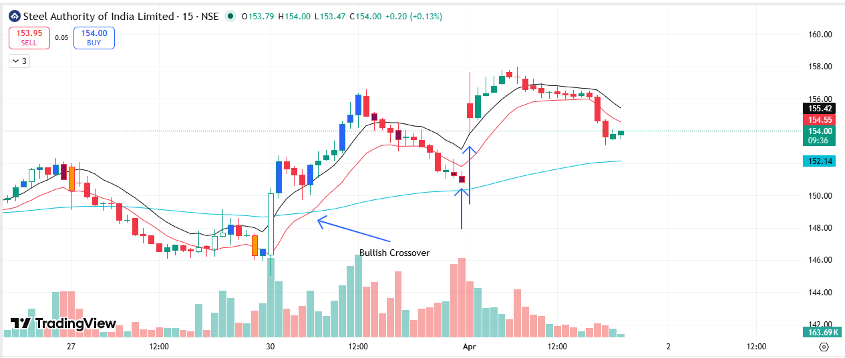
🔴 BEARISH SIGNAL --- CHOLAFIN

Nifty Bias : 🟢 LONG — Counter Trend ⚠️
Crossover : 2026-03-27 10:45 (5 days ago)
Pullback : 2026-04-01 09:15
High ₹1409.6 ≥ EMA9(High) ₹1370.47
Low ₹1395.8 (breakdown level)
Confirm : 2026-04-01 09:30 (+1 candle)
Close ₹1395.5 < Pullback Low ₹1395.8 (body breakdown)
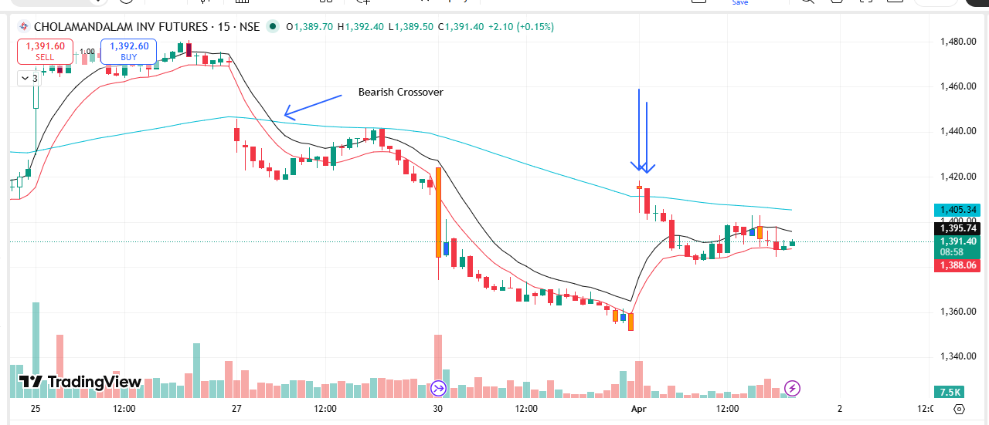
🔴 BEARISH SIGNAL --- DALBHARAT

Nifty Bias : 🟢 LONG — Counter Trend ⚠️
Crossover : 2026-03-30 10:30 (2 days ago)
Pullback : 2026-04-01 09:15
High ₹1850 ≥ EMA9(High) ₹1798.96
Low ₹1816.5 (breakdown level)
Confirm : 2026-04-01 09:30 (+1 candle)
Close ₹1810 < Pullback Low ₹1816.5 (body breakdown)
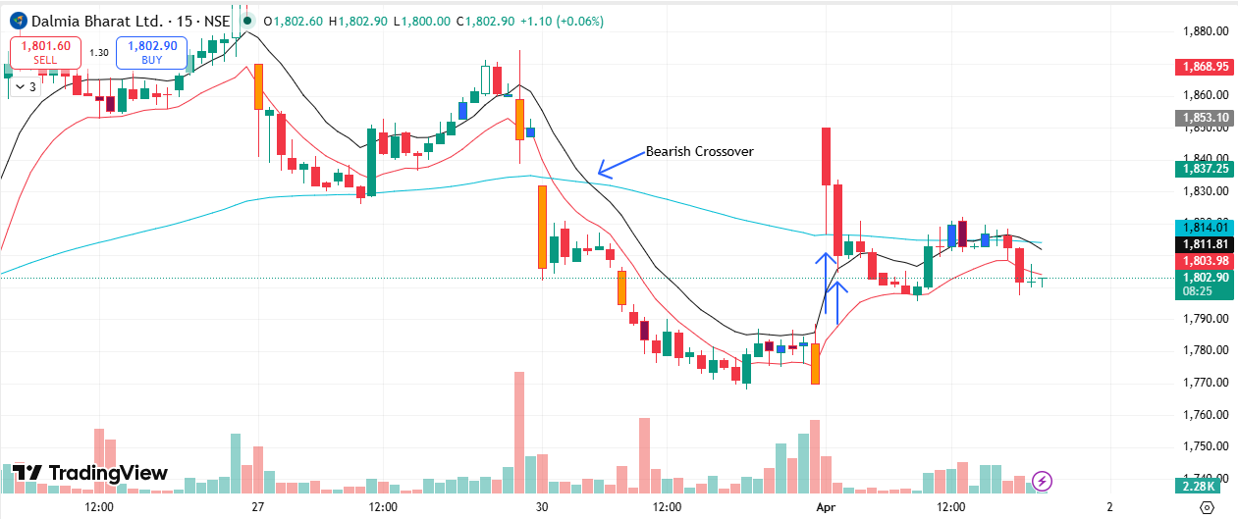
🔴 BEARISH SIGNAL --- INDIANB

Nifty Bias : 🟢 LONG — Counter Trend ⚠️
Crossover : 2026-03-27 12:00 (5 days ago)
Pullback : 2026-04-01 09:15
High ₹881.6 ≥ EMA9(High) ₹857.67
Low ₹872.05 (breakdown level)
Confirm : 2026-04-01 09:30 (+1 candle)
Close ₹871.15 < Pullback Low ₹872.05 (body breakdown)
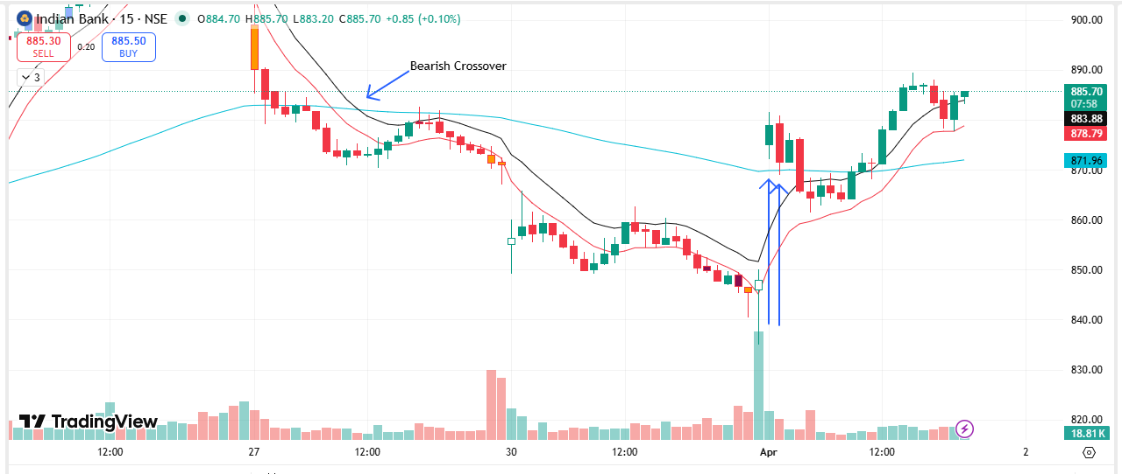
🔴 BEARISH SIGNAL --- IOC

Nifty Bias : 🟢 LONG — Counter Trend ⚠️
Crossover : 2026-03-27 09:30 (5 days ago)
Pullback : 2026-04-01 09:15
High ₹140 ≥ EMA9(High) ₹137.11
Low ₹137.1 (breakdown level)
Confirm : 2026-04-01 09:30 (+1 candle)
Close ₹136.89 < Pullback Low ₹137.1 (body breakdown)
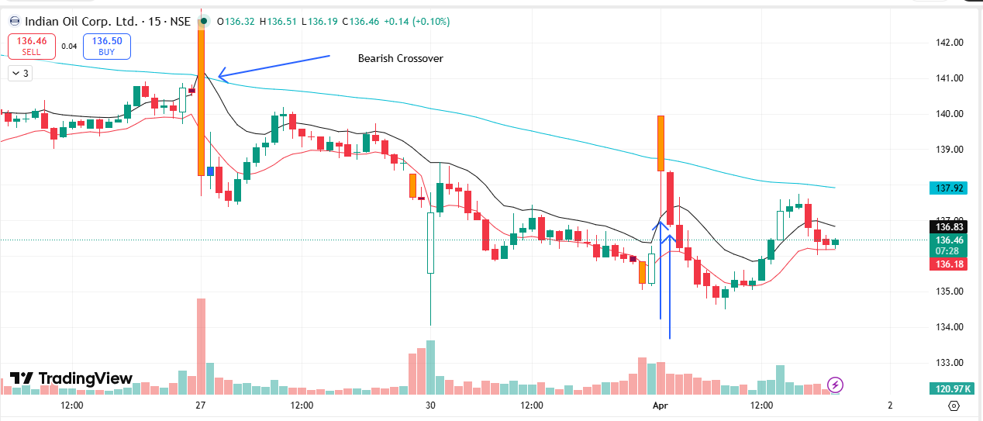
🔴 BEARISH SIGNAL --- JUBLFOOD

Nifty Bias : 🟢 LONG — Counter Trend ⚠️
Crossover : 2026-03-27 14:00 (5 days ago)
Pullback : 2026-04-01 09:15
High ₹452.6 ≥ EMA9(High) ₹439.94
Low ₹446.25 (breakdown level)
Confirm : 2026-04-01 09:30 (+1 candle)
Close ₹445.45 < Pullback Low ₹446.25 (body breakdown)
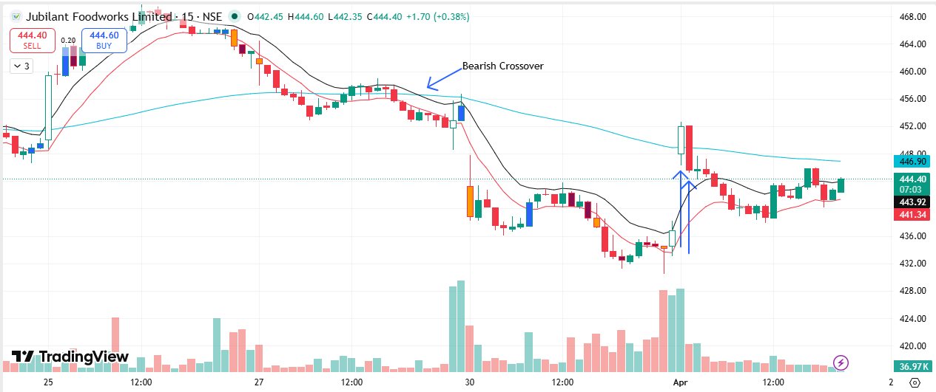
🔴 BEARISH SIGNAL --- LTF

Nifty Bias : 🟢 LONG — Counter Trend ⚠️
Crossover : 2026-03-27 10:15 (5 days ago)
Pullback : 2026-04-01 09:15
High ₹250.78 ≥ EMA9(High) ₹243.42
Low ₹246.41 (breakdown level)
Confirm : 2026-04-01 09:30 (+1 candle)
Close ₹245.86 < Pullback Low ₹246.41 (body breakdown)
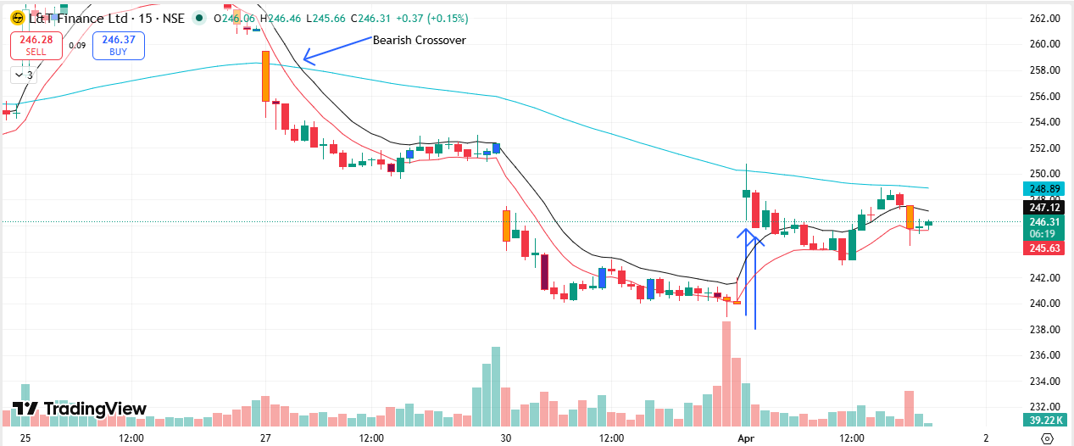
🔴 BEARISH SIGNAL --- NTPC

Nifty Bias : 🟢 LONG — Counter Trend ⚠️
Crossover : 2026-03-30 10:30 (2 days ago)
Pullback : 2026-04-01 09:15
High ₹381.9 ≥ EMA9(High) ₹374.89
Low ₹373.4 (breakdown level)
Confirm : 2026-04-01 09:30 (+1 candle)
Close ₹373.3 < Pullback Low ₹373.4 (body breakdown)
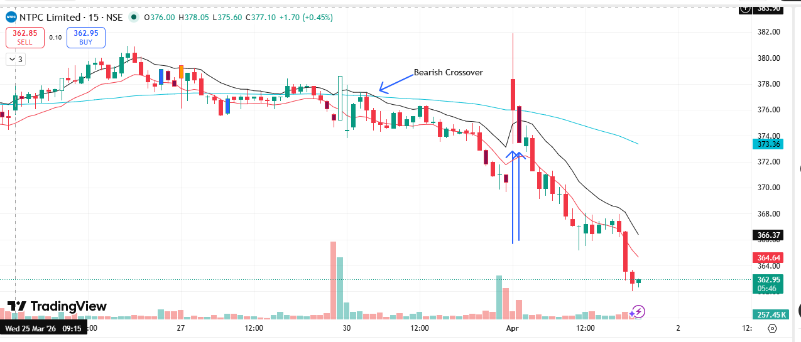
🔴 BEARISH SIGNAL --- SBICARD

Nifty Bias : 🟢 LONG — Counter Trend ⚠️
Crossover : 2026-03-27 11:45 (5 days ago)
Pullback : 2026-04-01 09:15
High ₹655.6 ≥ EMA9(High) ₹644.09
Low ₹647.55 (breakdown level)
Confirm : 2026-04-01 09:30 (+1 candle)
Close ₹644.6 < Pullback Low ₹647.55 (body breakdown)
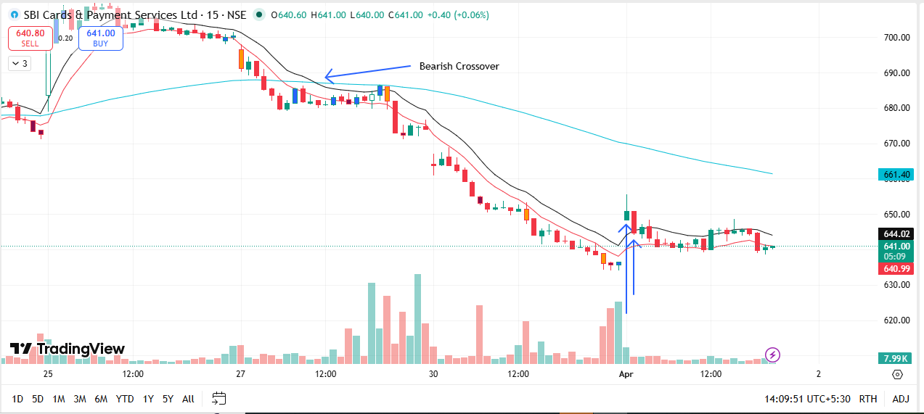
🔴 BEARISH SIGNAL --- TATACONSUM

Nifty Bias : 🟢 LONG — Counter Trend ⚠️
Crossover : 2026-03-30 09:15 (2 days ago)
Pullback : 2026-04-01 09:15
High ₹1036 ≥ EMA9(High) ₹1024.28
Low ₹1023.1 (breakdown level)
Confirm : 2026-04-01 09:30 (+1 candle)
Close ₹1022.1 < Pullback Low ₹1023.1 (body breakdown)
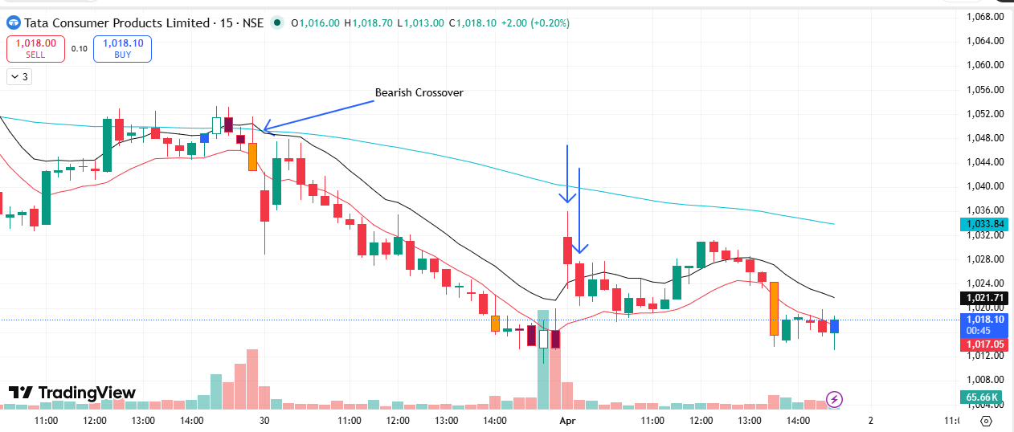
🔴 BEARISH SIGNAL --- UNIONBANK

Nifty Bias : 🟢 LONG — Counter Trend ⚠️
Crossover : 2026-03-27 11:00 (5 days ago)
Pullback : 2026-04-01 09:15
High ₹171 ≥ EMA9(High) ₹167.36
Low ₹169.3 (breakdown level)
Confirm : 2026-04-01 09:30 (+1 candle)
Close ₹168.89 < Pullback Low ₹169.3 (body breakdown)
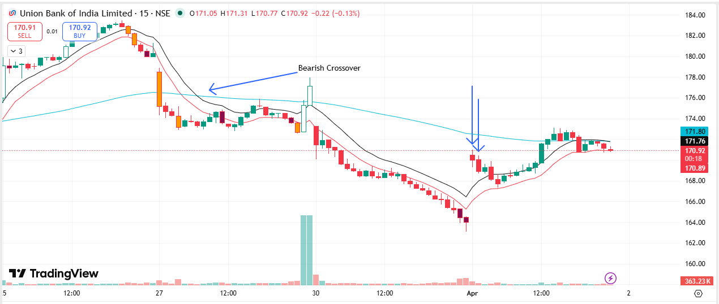
🔴 BEARISH SIGNAL --- BHEL

Nifty Bias : 🟢 LONG — Counter Trend ⚠️
Crossover : 2026-03-27 11:00 (5 days ago)
Pullback : 2026-04-01 09:30
High ₹257.28 ≥ EMA9(High) ₹252.1
Low ₹254.3 (breakdown level)
Confirm : 2026-04-01 09:45 (+1 candle)
Close ₹252.12 < Pullback Low ₹254.3 (body breakdown)
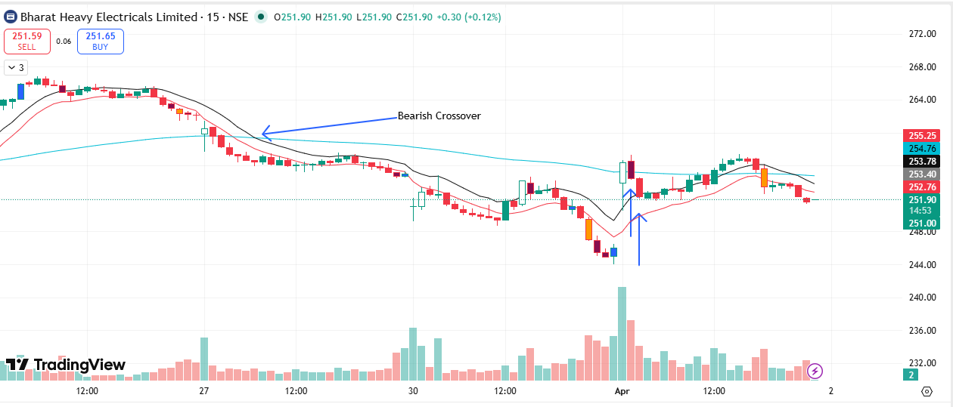
🔴 BEARISH SIGNAL --- BHARTIARTL

Nifty Bias : 🟢 LONG — Counter Trend ⚠️
Crossover : 2026-03-30 10:15 (2 days ago)
Pullback : 2026-04-01 09:30
High ₹1813 ≥ EMA9(High) ₹1801.33
Low ₹1806 (breakdown level)
Confirm : 2026-04-01 09:45 (+1 candle)
Close ₹1805.2 < Pullback Low ₹1806 (body breakdown)
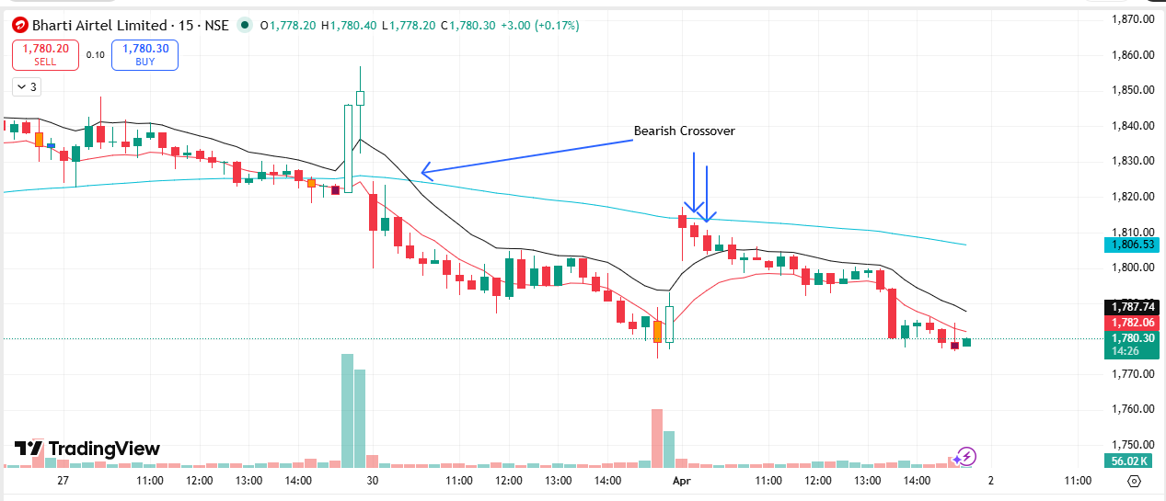
🔴 BEARISH SIGNAL --- BIOCON

Nifty Bias : 🟢 LONG — Counter Trend ⚠️
Crossover : 2026-03-27 11:30 (5 days ago)
Pullback : 2026-04-01 09:30
High ₹370.8 ≥ EMA9(High) ₹365.35
Low ₹367.55 (breakdown level)
Confirm : 2026-04-01 09:45 (+1 candle)
Close ₹367.25 < Pullback Low ₹367.55 (body breakdown)
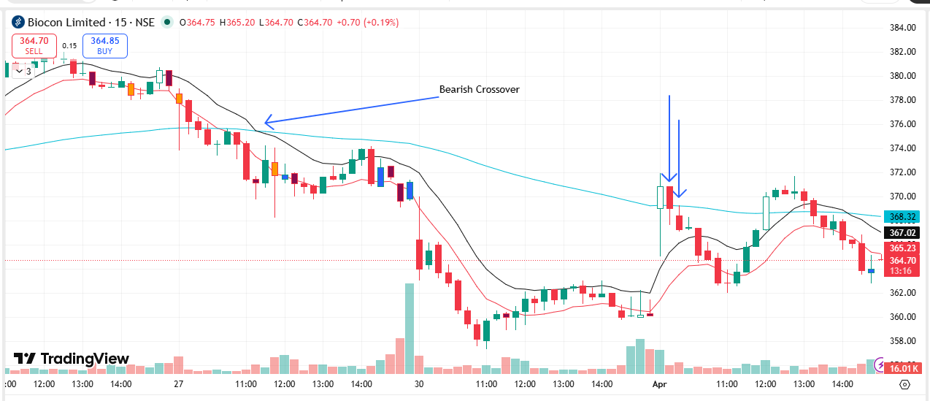
🔴 BEARISH SIGNAL --- DRREDDY

Nifty Bias : 🟢 LONG — Counter Trend ⚠️
Crossover : 2026-03-30 09:45 (2 days ago)
Pullback : 2026-04-01 09:30
High ₹1283 ≥ EMA9(High) ₹1269.52
Low ₹1275.7 (breakdown level)
Confirm : 2026-04-01 09:45 (+1 candle)
Close ₹1271.2 < Pullback Low ₹1275.7 (body breakdown)
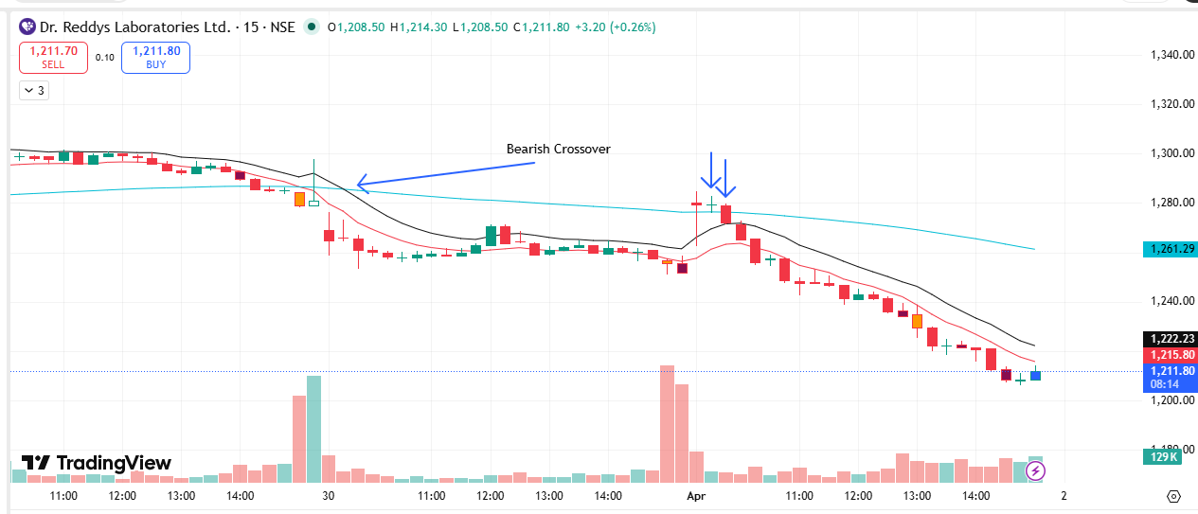
🔴 BEARISH SIGNAL --- GRASIM

Nifty Bias : 🟢 LONG — Counter Trend ⚠️
Crossover : 2026-03-30 10:15 (2 days ago)
Pullback : 2026-04-01 09:30
High ₹2608.7 ≥ EMA9(High) ₹2584.69
Low ₹2596.1 (breakdown level)
Confirm : 2026-04-01 09:45 (+1 candle)
Close ₹2595.2 < Pullback Low ₹2596.1 (body breakdown)
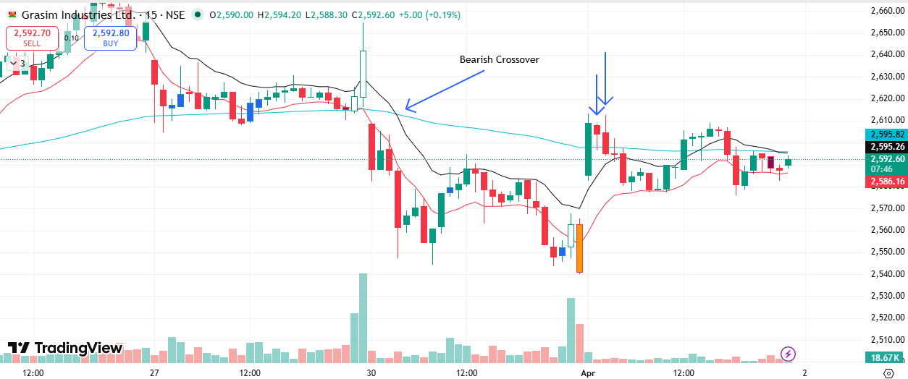
🔴 BEARISH SIGNAL --- JIOFIN

Nifty Bias : 🟢 LONG — Counter Trend ⚠️
Crossover : 2026-03-27 10:30 (5 days ago)
Pullback : 2026-04-01 09:15
High ₹233.04 ≥ EMA9(High) ₹226.89
Low ₹229 (breakdown level)
Confirm : 2026-04-01 09:45 (+2 candle)
Close ₹228.88 < Pullback Low ₹229 (body breakdown)

🔴 BEARISH SIGNAL --- KOTAKBANK

Nifty Bias : 🟢 LONG — Counter Trend ⚠️
Crossover : 2026-03-27 10:15 (5 days ago)
Pullback : 2026-04-01 09:30
High ₹362.8 ≥ EMA9(High) ₹358.61
Low ₹360.15 (breakdown level)
Confirm : 2026-04-01 09:45 (+1 candle)
Close ₹359.45 < Pullback Low ₹360.15 (body breakdown)

🔴 BEARISH SIGNAL --- MFSL

Nifty Bias : 🟢 LONG — Counter Trend ⚠️
Crossover : 2026-03-25 15:00 (7 days ago)
Pullback : 2026-04-01 09:30
High ₹1549.6 ≥ EMA9(High) ₹1517.74
Low ₹1536.9 (breakdown level)
Confirm : 2026-04-01 09:45 (+1 candle)
Close ₹1534.7 < Pullback Low ₹1536.9 (body breakdown)

🔴 BEARISH SIGNAL --- SUNPHARMA

Nifty Bias : 🟢 LONG — Counter Trend ⚠️
Crossover : 2026-03-30 10:45 (2 days ago)
Pullback : 2026-04-01 09:30
High ₹1788 ≥ EMA9(High) ₹1778.12
Low ₹1777.3 (breakdown level)
Confirm : 2026-04-01 09:45 (+1 candle)
Close ₹1777.1 < Pullback Low ₹1777.3 (body breakdown)

🔴 BEARISH SIGNAL --- TMPV

Nifty Bias : 🟢 LONG — Counter Trend ⚠️
Crossover : 2026-03-27 10:00 (5 days ago)
Pullback : 2026-04-01 09:30
High ₹306.1 ≥ EMA9(High) ₹301.7
Low ₹304.25 (breakdown level)
Confirm : 2026-04-01 09:45 (+1 candle)
Close ₹304.05 < Pullback Low ₹304.25 (body breakdown)

🔴 BEARISH SIGNAL --- 360ONE

Nifty Bias : 🟢 LONG — Counter Trend ⚠️
Crossover : 2026-03-20 14:45 (12 days ago)
Pullback : 2026-04-01 09:30
High ₹982.7 ≥ EMA9(High) ₹962.61
Low ₹975 (breakdown level)
Confirm : 2026-04-01 10:00 (+2 candle)
Close ₹972.6 < Pullback Low ₹975 (body breakdown)

🔴 BEARISH SIGNAL --- ABB

Nifty Bias : 🟢 LONG — Counter Trend ⚠️
Crossover : 2026-03-27 09:30 (5 days ago)
Pullback : 2026-04-01 09:45
High ₹6140 ≥ EMA9(High) ₹6073.67
Low ₹6123 (breakdown level)
Confirm : 2026-04-01 10:00 (+1 candle)
Close ₹6117 < Pullback Low ₹6123 (body breakdown)

🔴 BEARISH SIGNAL --- AUBANK

Nifty Bias : 🟢 LONG — Counter Trend ⚠️
Crossover : 2026-03-27 12:00 (5 days ago)
Pullback : 2026-04-01 09:30
High ₹876.55 ≥ EMA9(High) ₹856.7
Low ₹869.25 (breakdown level)
Confirm : 2026-04-01 10:00 (+2 candle)
Close ₹868.2 < Pullback Low ₹869.25 (body breakdown)

🔴 BEARISH SIGNAL --- ABCAPITAL

Nifty Bias : 🟢 LONG — Counter Trend ⚠️
Crossover : 2026-03-27 10:45 (5 days ago)
Pullback : 2026-04-01 09:15
High ₹304.6 ≥ EMA9(High) ₹296.81
Low ₹301.05 (breakdown level)
Confirm : 2026-04-01 10:00 (+3 candle)
Close ₹300.1 < Pullback Low ₹301.05 (body breakdown)

🔴 BEARISH SIGNAL --- BAJAJFINSV

Nifty Bias : 🟢 LONG — Counter Trend ⚠️
Crossover : 2026-03-27 10:45 (5 days ago)
Pullback : 2026-04-01 09:15
High ₹1683.1 ≥ EMA9(High) ₹1649.74
Low ₹1665.5 (breakdown level)
Confirm : 2026-04-01 10:00 (+3 candle)
Close ₹1665 < Pullback Low ₹1665.5 (body breakdown)

🔴 BEARISH SIGNAL --- BANKBARODA

Nifty Bias : 🟢 LONG — Counter Trend ⚠️
Crossover : 2026-03-27 09:15 (5 days ago)
Pullback : 2026-04-01 09:30
High ₹256.25 ≥ EMA9(High) ₹252.01
Low ₹252.51 (breakdown level)
Confirm : 2026-04-01 10:00 (+2 candle)
Close ₹252.25 < Pullback Low ₹252.51 (body breakdown)

🔴 BEARISH SIGNAL --- BANKINDIA

Nifty Bias : 🟢 LONG — Counter Trend ⚠️
Crossover : 2026-03-27 09:45 (5 days ago)
Pullback : 2026-04-01 09:30
High ₹142.26 ≥ EMA9(High) ₹139.98
Low ₹141.17 (breakdown level)
Confirm : 2026-04-01 10:00 (+2 candle)
Close ₹140.51 < Pullback Low ₹141.17 (body breakdown)

🔴 BEARISH SIGNAL --- BLUESTARCO

Nifty Bias : 🟢 LONG — Counter Trend ⚠️
Crossover : 2026-03-27 11:45 (5 days ago)
Pullback : 2026-04-01 09:30
High ₹1669.9 ≥ EMA9(High) ₹1638.64
Low ₹1650.5 (breakdown level)
Confirm : 2026-04-01 10:00 (+2 candle)
Close ₹1646.2 < Pullback Low ₹1650.5 (body breakdown)

🔴 BEARISH SIGNAL --- CANBK

Nifty Bias : 🟢 LONG — Counter Trend ⚠️
Crossover : 2026-03-27 10:00 (5 days ago)
Pullback : 2026-04-01 09:15
High ₹129.5 ≥ EMA9(High) ₹125.57
Low ₹127.22 (breakdown level)
Confirm : 2026-04-01 10:00 (+3 candle)
Close ₹127.02 < Pullback Low ₹127.22 (body breakdown)

🔴 BEARISH SIGNAL --- CYIENT

Nifty Bias : 🟢 LONG — Counter Trend ⚠️
Crossover : 2026-03-27 09:45 (5 days ago)
Pullback : 2026-04-01 09:45
High ₹811.25 ≥ EMA9(High) ₹784.29
Low ₹803.15 (breakdown level)
Confirm : 2026-04-01 10:00 (+1 candle)
Close ₹800.2 < Pullback Low ₹803.15 (body breakdown)

🔴 BEARISH SIGNAL --- DABUR

Nifty Bias : 🟢 LONG — Counter Trend ⚠️
Crossover : 2026-03-27 10:00 (5 days ago)
Pullback : 2026-04-01 09:30
High ₹420.95 ≥ EMA9(High) ₹415.03
Low ₹417.95 (breakdown level)
Confirm : 2026-04-01 10:00 (+2 candle)
Close ₹417.85 < Pullback Low ₹417.95 (body breakdown)

🔴 BEARISH SIGNAL --- HAVELLS

Nifty Bias : 🟢 LONG — Counter Trend ⚠️
Crossover : 2026-03-27 10:15 (5 days ago)
Pullback : 2026-04-01 09:30
High ₹1226 ≥ EMA9(High) ₹1205.74
Low ₹1216 (breakdown level)
Confirm : 2026-04-01 10:00 (+2 candle)
Close ₹1212.3 < Pullback Low ₹1216 (body breakdown)

🔴 BEARISH SIGNAL --- HEROMOTOCO

Nifty Bias : 🟢 LONG — Counter Trend ⚠️
Crossover : 2026-03-27 10:00 (5 days ago)
Pullback : 2026-04-01 09:30
High ₹5218 ≥ EMA9(High) ₹5146.86
Low ₹5179 (breakdown level)
Confirm : 2026-04-01 10:00 (+2 candle)
Close ₹5169.5 < Pullback Low ₹5179 (body breakdown)

🔴 BEARISH SIGNAL --- ICICIBANK

Nifty Bias : 🟢 LONG — Counter Trend ⚠️
Crossover : 2026-03-27 13:30 (5 days ago)
Pullback : 2026-04-01 09:45
High ₹1227 ≥ EMA9(High) ₹1221.39
Low ₹1223.3 (breakdown level)
Confirm : 2026-04-01 10:00 (+1 candle)
Close ₹1222.3 < Pullback Low ₹1223.3 (body breakdown)

🔴 BEARISH SIGNAL --- ICICIGI

Nifty Bias : 🟢 LONG — Counter Trend ⚠️
Crossover : 2026-03-27 10:45 (5 days ago)
Pullback : 2026-04-01 09:30
High ₹1747 ≥ EMA9(High) ₹1728.28
Low ₹1733.1 (breakdown level)
Confirm : 2026-04-01 10:00 (+2 candle)
Close ₹1729.3 < Pullback Low ₹1733.1 (body breakdown)

🔴 BEARISH SIGNAL --- ICICIPRULI

Nifty Bias : 🟢 LONG — Counter Trend ⚠️
Crossover : 2026-03-25 13:15 (7 days ago)
Pullback : 2026-04-01 09:15
High ₹531.8 ≥ EMA9(High) ₹515.38
Low ₹516.9 (breakdown level)
Confirm : 2026-04-01 10:00 (+3 candle)
Close ₹514.55 < Pullback Low ₹516.9 (body breakdown)

🔴 BEARISH SIGNAL --- IGL

Nifty Bias : 🟢 LONG — Counter Trend ⚠️
Crossover : 2026-03-25 13:45 (7 days ago)
Pullback : 2026-04-01 09:30
High ₹150.12 ≥ EMA9(High) ₹148.04
Low ₹149.02 (breakdown level)
Confirm : 2026-04-01 10:00 (+2 candle)
Close ₹148.7 < Pullback Low ₹149.02 (body breakdown)

🔴 BEARISH SIGNAL --- JSWENERGY

Nifty Bias : 🟢 LONG — Counter Trend ⚠️
Crossover : 2026-03-27 10:15 (5 days ago)
Pullback : 2026-04-01 09:45
High ₹485.5 ≥ EMA9(High) ₹479.57
Low ₹482.4 (breakdown level)
Confirm : 2026-04-01 10:00 (+1 candle)
Close ₹482 < Pullback Low ₹482.4 (body breakdown)

🔴 BEARISH SIGNAL --- KFINTECH

Nifty Bias : 🟢 LONG — Counter Trend ⚠️
Crossover : 2026-03-27 13:45 (5 days ago)
Pullback : 2026-04-01 09:30
High ₹920.7 ≥ EMA9(High) ₹899.01
Low ₹912.8 (breakdown level)
Confirm : 2026-04-01 10:00 (+2 candle)
Close ₹912 < Pullback Low ₹912.8 (body breakdown)

🔴 BEARISH SIGNAL --- LICI

Nifty Bias : 🟢 LONG — Counter Trend ⚠️
Crossover : 2026-03-30 09:15 (2 days ago)
Pullback : 2026-04-01 09:45
High ₹751.7 ≥ EMA9(High) ₹739.29
Low ₹748.55 (breakdown level)
Confirm : 2026-04-01 10:00 (+1 candle)
Close ₹748.3 < Pullback Low ₹748.55 (body breakdown)

🔴 BEARISH SIGNAL --- NESTLEIND

Nifty Bias : 🟢 LONG — Counter Trend ⚠️
Crossover : 2026-03-30 10:00 (2 days ago)
Pullback : 2026-04-01 09:30
High ₹1191.5 ≥ EMA9(High) ₹1185.02
Low ₹1179.5 (breakdown level)
Confirm : 2026-04-01 10:00 (+2 candle)
Close ₹1178.3 < Pullback Low ₹1179.5 (body breakdown)

🔴 BEARISH SIGNAL --- PFC

Nifty Bias : 🟢 LONG — Counter Trend ⚠️
Crossover : 2026-03-25 14:15 (7 days ago)
Pullback : 2026-04-01 09:45
High ₹395.1 ≥ EMA9(High) ₹389.39
Low ₹393 (breakdown level)
Confirm : 2026-04-01 10:00 (+1 candle)
Close ₹392.95 < Pullback Low ₹393 (body breakdown)

🔴 BEARISH SIGNAL --- SBILIFE

Nifty Bias : 🟢 LONG — Counter Trend ⚠️
Crossover : 2026-03-19 12:00 (13 days ago)
Pullback : 2026-04-01 09:15
High ₹1845.6 ≥ EMA9(High) ₹1802.93
Low ₹1791.7 (breakdown level)
Confirm : 2026-04-01 10:00 (+3 candle)
Close ₹1789.4 < Pullback Low ₹1791.7 (body breakdown)

🔴 BEARISH SIGNAL --- MOTHERSON

Nifty Bias : 🟢 LONG — Counter Trend ⚠️
Crossover : 2026-03-27 10:15 (5 days ago)
Pullback : 2026-04-01 09:45
High ₹109.95 ≥ EMA9(High) ₹107.99
Low ₹109.1 (breakdown level)
Confirm : 2026-04-01 10:00 (+1 candle)
Close ₹108.99 < Pullback Low ₹109.1 (body breakdown)

🔴 BEARISH SIGNAL --- SBIN

Nifty Bias : 🟢 LONG — Counter Trend ⚠️
Crossover : 2026-03-27 11:00 (5 days ago)
Pullback : 2026-04-01 09:30
High ₹1013 ≥ EMA9(High) ₹996.16
Low ₹1004.3 (breakdown level)
Confirm : 2026-04-01 10:00 (+2 candle)
Close ₹1004 < Pullback Low ₹1004.3 (body breakdown)

🔴 BEARISH SIGNAL --- TORNTPOWER

Nifty Bias : 🟢 LONG — Counter Trend ⚠️
Crossover : 2026-03-25 15:00 (7 days ago)
Pullback : 2026-04-01 09:30
High ₹1352 ≥ EMA9(High) ₹1328.58
Low ₹1335.5 (breakdown level)
Confirm : 2026-04-01 10:00 (+2 candle)
Close ₹1333.8 < Pullback Low ₹1335.5 (body breakdown)

🔴 BEARISH SIGNAL --- UNOMINDA

Nifty Bias : 🟢 LONG — Counter Trend ⚠️
Crossover : 2026-03-27 11:30 (5 days ago)
Pullback : 2026-04-01 09:15
High ₹1061 ≥ EMA9(High) ₹1042.19
Low ₹1050.3 (breakdown level)
Confirm : 2026-04-01 10:00 (+3 candle)
Close ₹1046.3 < Pullback Low ₹1050.3 (body breakdown)

🔴 BEARISH SIGNAL --- ULTRACEMCO

Nifty Bias : 🟢 LONG — Counter Trend ⚠️
Crossover : 2026-03-30 11:00 (2 days ago)
Pullback : 2026-04-01 09:30
High ₹10909 ≥ EMA9(High) ₹10866.78
Low ₹10839 (breakdown level)
Confirm : 2026-04-01 10:00 (+2 candle)
Close ₹10803 < Pullback Low ₹10839 (body breakdown)

🔴 BEARISH SIGNAL --- VOLTAS

Nifty Bias : 🟢 LONG — Counter Trend ⚠️
Crossover : 2026-03-30 09:15 (2 days ago)
Pullback : 2026-04-01 09:45
High ₹1306.5 ≥ EMA9(High) ₹1295.48
Low ₹1294.2 (breakdown level)
Confirm : 2026-04-01 10:00 (+1 candle)
Close ₹1291.3 < Pullback Low ₹1294.2 (body breakdown)

🔴 BEARISH SIGNAL --- ASHOKLEY

Nifty Bias : 🟢 LONG — Counter Trend ⚠️
Crossover : 2026-03-27 10:00 (5 days ago)
Pullback : 2026-04-01 09:30
High ₹159.06 ≥ EMA9(High) ₹157.44
Low ₹155.9 (breakdown level)
Confirm : 2026-04-01 10:15 (+3 candle)
Close ₹154.57 < Pullback Low ₹155.9 (body breakdown)

🔴 BEARISH SIGNAL --- AXISBANK

Nifty Bias : 🟢 LONG — Counter Trend ⚠️
Crossover : 2026-03-30 09:15 (2 days ago)
Pullback : 2026-04-01 09:30
High ₹1200.9 ≥ EMA9(High) ₹1179.28
Low ₹1192.7 (breakdown level)
Confirm : 2026-04-01 10:15 (+3 candle)
Close ₹1190.2 < Pullback Low ₹1192.7 (body breakdown)

🔴 BEARISH SIGNAL --- BANDHANBNK

Nifty Bias : 🟢 LONG — Counter Trend ⚠️
Crossover : 2026-03-27 09:45 (5 days ago)
Pullback : 2026-04-01 09:30
High ₹148.18 ≥ EMA9(High) ₹144.27
Low ₹146.51 (breakdown level)
Confirm : 2026-04-01 10:15 (+3 candle)
Close ₹146.3 < Pullback Low ₹146.51 (body breakdown)

🔴 BEARISH SIGNAL --- BRITANNIA

Nifty Bias : 🟢 LONG — Counter Trend ⚠️
Crossover : 2026-03-27 11:15 (5 days ago)
Pullback : 2026-04-01 09:45
High ₹5520 ≥ EMA9(High) ₹5492.66
Low ₹5484.5 (breakdown level)
Confirm : 2026-04-01 10:15 (+2 candle)
Close ₹5480.5 < Pullback Low ₹5484.5 (body breakdown)

🔴 BEARISH SIGNAL --- COLPAL

Nifty Bias : 🟢 LONG — Counter Trend ⚠️
Crossover : 2026-03-27 14:00 (5 days ago)
Pullback : 2026-04-01 09:45
High ₹1843.3 ≥ EMA9(High) ₹1820.84
Low ₹1833.5 (breakdown level)
Confirm : 2026-04-01 10:15 (+2 candle)
Close ₹1829.6 < Pullback Low ₹1833.5 (body breakdown)

🔴 BEARISH SIGNAL --- CROMPTON

Nifty Bias : 🟢 LONG — Counter Trend ⚠️
Crossover : 2026-03-27 10:15 (5 days ago)
Pullback : 2026-04-01 10:00
High ₹232.4 ≥ EMA9(High) ₹229.44
Low ₹231.3 (breakdown level)
Confirm : 2026-04-01 10:15 (+1 candle)
Close ₹230.83 < Pullback Low ₹231.3 (body breakdown)

🔴 BEARISH SIGNAL --- DIXON

Nifty Bias : 🟢 LONG — Counter Trend ⚠️
Crossover : 2026-03-27 10:30 (5 days ago)
Pullback : 2026-04-01 10:00
High ₹10149 ≥ EMA9(High) ₹10001.89
Low ₹10084 (breakdown level)
Confirm : 2026-04-01 10:15 (+1 candle)
Close ₹10066 < Pullback Low ₹10084 (body breakdown)

🔴 BEARISH SIGNAL --- EICHERMOT

Nifty Bias : 🟢 LONG — Counter Trend ⚠️
Crossover : 2026-03-27 10:30 (5 days ago)
Pullback : 2026-04-01 09:45
High ₹6840 ≥ EMA9(High) ₹6729.67
Low ₹6796 (breakdown level)
Confirm : 2026-04-01 10:15 (+2 candle)
Close ₹6788 < Pullback Low ₹6796 (body breakdown)

🔴 BEARISH SIGNAL --- EXIDEIND

Nifty Bias : 🟢 LONG — Counter Trend ⚠️
Crossover : 2026-03-30 09:15 (2 days ago)
Pullback : 2026-04-01 10:00
High ₹301.2 ≥ EMA9(High) ₹297.08
Low ₹299.3 (breakdown level)
Confirm : 2026-04-01 10:15 (+1 candle)
Close ₹299.2 < Pullback Low ₹299.3 (body breakdown)

🔴 BEARISH SIGNAL --- FORTIS

Nifty Bias : 🟢 LONG — Counter Trend ⚠️
Crossover : 2026-03-30 09:15 (2 days ago)
Pullback : 2026-04-01 09:30
High ₹812.75 ≥ EMA9(High) ₹805.33
Low ₹806.2 (breakdown level)
Confirm : 2026-04-01 10:15 (+3 candle)
Close ₹803.6 < Pullback Low ₹806.2 (body breakdown)

🔴 BEARISH SIGNAL --- GODREJCP

Nifty Bias : 🟢 LONG — Counter Trend ⚠️
Crossover : 2026-03-27 11:45 (5 days ago)
Pullback : 2026-04-01 09:45
High ₹1006.5 ≥ EMA9(High) ₹998.98
Low ₹998.45 (breakdown level)
Confirm : 2026-04-01 10:15 (+2 candle)
Close ₹997.15 < Pullback Low ₹998.45 (body breakdown)

🔴 BEARISH SIGNAL --- HDFCBANK

Nifty Bias : 🟢 LONG — Counter Trend ⚠️
Crossover : 2026-03-27 09:45 (5 days ago)
Pullback : 2026-04-01 09:30
High ₹751.9 ≥ EMA9(High) ₹742.73
Low ₹744.6 (breakdown level)
Confirm : 2026-04-01 10:15 (+3 candle)
Close ₹741.45 < Pullback Low ₹744.6 (body breakdown)

🔴 BEARISH SIGNAL --- HAL

Nifty Bias : 🟢 LONG — Counter Trend ⚠️
Crossover : 2026-03-19 09:45 (13 days ago)
Pullback : 2026-04-01 09:45
High ₹3658 ≥ EMA9(High) ₹3574.33
Low ₹3621.2 (breakdown level)
Confirm : 2026-04-01 10:15 (+2 candle)
Close ₹3617.6 < Pullback Low ₹3621.2 (body breakdown)

🔴 BEARISH SIGNAL --- HINDUNILVR

Nifty Bias : 🟢 LONG — Counter Trend ⚠️
Crossover : 2026-03-27 11:30 (5 days ago)
Pullback : 2026-04-01 09:30
High ₹2092.4 ≥ EMA9(High) ₹2074.46
Low ₹2081.5 (breakdown level)
Confirm : 2026-04-01 10:15 (+3 candle)
Close ₹2076.4 < Pullback Low ₹2081.5 (body breakdown)

🔴 BEARISH SIGNAL --- HUDCO

Nifty Bias : 🟢 LONG — Counter Trend ⚠️
Crossover : 2026-03-27 11:00 (5 days ago)
Pullback : 2026-04-01 09:30
High ₹168.72 ≥ EMA9(High) ₹163.57
Low ₹166.67 (breakdown level)
Confirm : 2026-04-01 10:15 (+3 candle)
Close ₹166.24 < Pullback Low ₹166.67 (body breakdown)

🔴 BEARISH SIGNAL --- IDFCFIRSTB

Nifty Bias : 🟢 LONG — Counter Trend ⚠️
Crossover : 2026-03-27 10:45 (5 days ago)
Pullback : 2026-04-01 09:30
High ₹60.89 ≥ EMA9(High) ₹59.91
Low ₹60.32 (breakdown level)
Confirm : 2026-04-01 10:15 (+3 candle)
Close ₹60.03 < Pullback Low ₹60.32 (body breakdown)

🔴 BEARISH SIGNAL --- IIFL

Nifty Bias : 🟢 LONG — Counter Trend ⚠️
Crossover : 2026-03-27 09:45 (5 days ago)
Pullback : 2026-04-01 10:00
High ₹443.55 ≥ EMA9(High) ₹440.15
Low ₹439.6 (breakdown level)
Confirm : 2026-04-01 10:15 (+1 candle)
Close ₹439.4 < Pullback Low ₹439.6 (body breakdown)

🔴 BEARISH SIGNAL --- ITC

Nifty Bias : 🟢 LONG — Counter Trend ⚠️
Crossover : 2026-03-27 14:00 (5 days ago)
Pullback : 2026-04-01 09:30
High ₹294.45 ≥ EMA9(High) ₹291.02
Low ₹292.1 (breakdown level)
Confirm : 2026-04-01 10:15 (+3 candle)
Close ₹291.5 < Pullback Low ₹292.1 (body breakdown)

🔴 BEARISH SIGNAL --- IEX

Nifty Bias : 🟢 LONG — Counter Trend ⚠️
Crossover : 2026-03-27 14:45 (5 days ago)
Pullback : 2026-04-01 10:00
High ₹119.77 ≥ EMA9(High) ₹118.03
Low ₹119.4 (breakdown level)
Confirm : 2026-04-01 10:15 (+1 candle)
Close ₹119.17 < Pullback Low ₹119.4 (body breakdown)

🔴 BEARISH SIGNAL --- IRFC

Nifty Bias : 🟢 LONG — Counter Trend ⚠️
Crossover : 2026-03-27 10:30 (5 days ago)
Pullback : 2026-04-01 10:00
High ₹92.24 ≥ EMA9(High) ₹90.52
Low ₹91.81 (breakdown level)
Confirm : 2026-04-01 10:15 (+1 candle)
Close ₹91.64 < Pullback Low ₹91.81 (body breakdown)

🔴 BEARISH SIGNAL --- LTM

Nifty Bias : 🟢 LONG — Counter Trend ⚠️
Crossover : 2026-03-27 15:15 (5 days ago)
Pullback : 2026-04-01 10:00
High ₹4247.6 ≥ EMA9(High) ₹4161.97
Low ₹4228.2 (breakdown level)
Confirm : 2026-04-01 10:15 (+1 candle)
Close ₹4222.3 < Pullback Low ₹4228.2 (body breakdown)

🔴 BEARISH SIGNAL --- LODHA

Nifty Bias : 🟢 LONG — Counter Trend ⚠️
Crossover : 2026-03-19 09:30 (13 days ago)
Pullback : 2026-04-01 09:45
High ₹694.85 ≥ EMA9(High) ₹686.58
Low ₹685.9 (breakdown level)
Confirm : 2026-04-01 10:15 (+2 candle)
Close ₹684.55 < Pullback Low ₹685.9 (body breakdown)

🔴 BEARISH SIGNAL --- PAYTM

Nifty Bias : 🟢 LONG — Counter Trend ⚠️
Crossover : 2026-03-27 11:15 (5 days ago)
Pullback : 2026-04-01 10:00
High ₹997.95 ≥ EMA9(High) ₹987.54
Low ₹993.4 (breakdown level)
Confirm : 2026-04-01 10:15 (+1 candle)
Close ₹993.35 < Pullback Low ₹993.4 (body breakdown)

🔴 BEARISH SIGNAL --- PGEL

Nifty Bias : 🟢 LONG — Counter Trend ⚠️
Crossover : 2026-03-27 11:00 (5 days ago)
Pullback : 2026-04-01 10:00
High ₹500 ≥ EMA9(High) ₹490.3
Low ₹496 (breakdown level)
Confirm : 2026-04-01 10:15 (+1 candle)
Close ₹495.25 < Pullback Low ₹496 (body breakdown)

🔴 BEARISH SIGNAL --- PIIND

Nifty Bias : 🟢 LONG — Counter Trend ⚠️
Crossover : 2026-03-27 15:00 (5 days ago)
Pullback : 2026-04-01 10:00
High ₹2849.1 ≥ EMA9(High) ₹2792.01
Low ₹2828.2 (breakdown level)
Confirm : 2026-04-01 10:15 (+1 candle)
Close ₹2823.9 < Pullback Low ₹2828.2 (body breakdown)

🔴 BEARISH SIGNAL --- PATANJALI

Nifty Bias : 🟢 LONG — Counter Trend ⚠️
Crossover : 2026-03-30 09:15 (2 days ago)
Pullback : 2026-04-01 09:30
High ₹471.25 ≥ EMA9(High) ₹465.1
Low ₹468 (breakdown level)
Confirm : 2026-04-01 10:15 (+3 candle)
Close ₹467.3 < Pullback Low ₹468 (body breakdown)

🔴 BEARISH SIGNAL --- PIDILITIND

Nifty Bias : 🟢 LONG — Counter Trend ⚠️
Crossover : 2026-03-27 11:00 (5 days ago)
Pullback : 2026-04-01 09:30
High ₹1317.6 ≥ EMA9(High) ₹1302.25
Low ₹1307.4 (breakdown level)
Confirm : 2026-04-01 10:15 (+3 candle)
Close ₹1305 < Pullback Low ₹1307.4 (body breakdown)

🔴 BEARISH SIGNAL --- PRESTIGE

Nifty Bias : 🟢 LONG — Counter Trend ⚠️
Crossover : 2026-03-27 09:30 (5 days ago)
Pullback : 2026-04-01 09:45
High ₹1163.8 ≥ EMA9(High) ₹1146.95
Low ₹1154.5 (breakdown level)
Confirm : 2026-04-01 10:15 (+2 candle)
Close ₹1153.1 < Pullback Low ₹1154.5 (body breakdown)

🔴 BEARISH SIGNAL --- PNB

Nifty Bias : 🟢 LONG — Counter Trend ⚠️
Crossover : 2026-03-27 09:45 (5 days ago)
Pullback : 2026-04-01 09:45
High ₹104.66 ≥ EMA9(High) ₹103
Low ₹103.64 (breakdown level)
Confirm : 2026-04-01 10:15 (+2 candle)
Close ₹103.48 < Pullback Low ₹103.64 (body breakdown)

🔴 BEARISH SIGNAL --- RECLTD

Nifty Bias : 🟢 LONG — Counter Trend ⚠️
Crossover : 2026-03-27 10:30 (5 days ago)
Pullback : 2026-04-01 10:00
High ₹320.75 ≥ EMA9(High) ₹315.3
Low ₹318.15 (breakdown level)
Confirm : 2026-04-01 10:15 (+1 candle)
Close ₹318.1 < Pullback Low ₹318.15 (body breakdown)

🔴 BEARISH SIGNAL --- RVNL

Nifty Bias : 🟢 LONG — Counter Trend ⚠️
Crossover : 2026-03-30 09:30 (2 days ago)
Pullback : 2026-04-01 10:00
High ₹265.2 ≥ EMA9(High) ₹259.73
Low ₹262.42 (breakdown level)
Confirm : 2026-04-01 10:15 (+1 candle)
Close ₹261.76 < Pullback Low ₹262.42 (body breakdown)

🔴 BEARISH SIGNAL --- RELIANCE

Nifty Bias : 🟢 LONG — Counter Trend ⚠️
Crossover : 2026-03-27 09:30 (5 days ago)
Pullback : 2026-04-01 10:00
High ₹1379 ≥ EMA9(High) ₹1366.23
Low ₹1373.5 (breakdown level)
Confirm : 2026-04-01 10:15 (+1 candle)
Close ₹1370.5 < Pullback Low ₹1373.5 (body breakdown)

🔴 BEARISH SIGNAL --- SHREECEM

Nifty Bias : 🟢 LONG — Counter Trend ⚠️
Crossover : 2026-03-30 10:45 (2 days ago)
Pullback : 2026-04-01 09:30
High ₹23510 ≥ EMA9(High) ₹23324.65
Low ₹23330 (breakdown level)
Confirm : 2026-04-01 10:15 (+3 candle)
Close ₹23235 < Pullback Low ₹23330 (body breakdown)

🔴 BEARISH SIGNAL --- SHRIRAMFIN

Nifty Bias : 🟢 LONG — Counter Trend ⚠️
Crossover : 2026-03-27 10:15 (5 days ago)
Pullback : 2026-04-01 09:30
High ₹921.3 ≥ EMA9(High) ₹893.74
Low ₹908.5 (breakdown level)
Confirm : 2026-04-01 10:15 (+3 candle)
Close ₹908.25 < Pullback Low ₹908.5 (body breakdown)

🔴 BEARISH SIGNAL --- SIEMENS

Nifty Bias : 🟢 LONG — Counter Trend ⚠️
Crossover : 2026-03-30 09:15 (2 days ago)
Pullback : 2026-04-01 09:45
High ₹3058 ≥ EMA9(High) ₹3007.01
Low ₹3042.6 (breakdown level)
Confirm : 2026-04-01 10:15 (+2 candle)
Close ₹3040.9 < Pullback Low ₹3042.6 (body breakdown)

🔴 BEARISH SIGNAL --- TATAPOWER

Nifty Bias : 🟢 LONG — Counter Trend ⚠️
Crossover : 2026-03-25 15:15 (7 days ago)
Pullback : 2026-04-01 09:30
High ₹387 ≥ EMA9(High) ₹384.02
Low ₹383.7 (breakdown level)
Confirm : 2026-04-01 10:15 (+3 candle)
Close ₹381.9 < Pullback Low ₹383.7 (body breakdown)

🔴 BEARISH SIGNAL --- TATATECH

Nifty Bias : 🟢 LONG — Counter Trend ⚠️
Crossover : 2026-03-30 09:30 (2 days ago)
Pullback : 2026-04-01 10:00
High ₹538.65 ≥ EMA9(High) ₹527.48
Low ₹536.25 (breakdown level)
Confirm : 2026-04-01 10:15 (+1 candle)
Close ₹534.35 < Pullback Low ₹536.25 (body breakdown)

🔴 BEARISH SIGNAL --- INDHOTEL

Nifty Bias : 🟢 LONG — Counter Trend ⚠️
Crossover : 2026-03-27 11:45 (5 days ago)
Pullback : 2026-04-01 10:00
High ₹595.5 ≥ EMA9(High) ₹586.72
Low ₹589 (breakdown level)
Confirm : 2026-04-01 10:15 (+1 candle)
Close ₹587.3 < Pullback Low ₹589 (body breakdown)

🔴 BEARISH SIGNAL --- UPL

Nifty Bias : 🟢 LONG — Counter Trend ⚠️
Crossover : 2026-03-27 10:45 (5 days ago)
Pullback : 2026-04-01 10:00
High ₹596.4 ≥ EMA9(High) ₹586.45
Low ₹593.35 (breakdown level)
Confirm : 2026-04-01 10:15 (+1 candle)
Close ₹591.45 < Pullback Low ₹593.35 (body breakdown)

🔴 BEARISH SIGNAL --- IDEA

Nifty Bias : 🟢 LONG — Counter Trend ⚠️
Crossover : 2026-03-27 10:00 (5 days ago)
Pullback : 2026-04-01 09:30
High ₹8.89 ≥ EMA9(High) ₹8.73
Low ₹8.78 (breakdown level)
Confirm : 2026-04-01 10:15 (+3 candle)
Close ₹8.74 < Pullback Low ₹8.78 (body breakdown)

🔴 BEARISH SIGNAL --- DLF

Nifty Bias : 🟢 LONG — Counter Trend ⚠️
Crossover : 2026-03-27 09:45 (5 days ago)
Pullback : 2026-04-01 10:00
High ₹524.55 ≥ EMA9(High) ₹515.8
Low ₹520.2 (breakdown level)
Confirm : 2026-04-01 10:30 (+2 candle)
Close ₹519.3 < Pullback Low ₹520.2 (body breakdown)

🔴 BEARISH SIGNAL --- HDFCAMC

Nifty Bias : 🟢 LONG — Counter Trend ⚠️
Crossover : 2026-03-27 10:00 (5 days ago)
Pullback : 2026-04-01 09:45
High ₹2317.9 ≥ EMA9(High) ₹2278.39
Low ₹2301.7 (breakdown level)
Confirm : 2026-04-01 10:30 (+3 candle)
Close ₹2297.8 < Pullback Low ₹2301.7 (body breakdown)

🔴 BEARISH SIGNAL --- IREDA

Nifty Bias : 🟢 LONG — Counter Trend ⚠️
Crossover : 2026-03-27 14:00 (5 days ago)
Pullback : 2026-04-01 09:45
High ₹114.89 ≥ EMA9(High) ₹112.75
Low ₹113.88 (breakdown level)
Confirm : 2026-04-01 10:15 (+2 candle)
Close ₹113.8 < Pullback Low ₹113.88 (body breakdown)

🔴 BEARISH SIGNAL --- INDUSINDBK

Nifty Bias : 🟢 LONG — Counter Trend ⚠️
Crossover : 2026-03-27 10:30 (5 days ago)
Pullback : 2026-04-01 09:30
High ₹785 ≥ EMA9(High) ₹768.02
Low ₹777.75 (breakdown level)
Confirm : 2026-04-01 10:15 (+3 candle)
Close ₹773.4 < Pullback Low ₹777.75 (body breakdown)

🔴 BEARISH SIGNAL --- OBEROIRLTY

Nifty Bias : 🟢 LONG — Counter Trend ⚠️
Crossover : 2026-03-30 10:45 (2 days ago)
Pullback : 2026-04-01 10:00
High ₹1455.7 ≥ EMA9(High) ₹1444.49
Low ₹1449.4 (breakdown level)
Confirm : 2026-04-01 10:30 (+2 candle)
Close ₹1448 < Pullback Low ₹1449.4 (body breakdown)

🔴 BEARISH SIGNAL --- YESBANK

Nifty Bias : 🟢 LONG — Counter Trend ⚠️
Crossover : 2026-03-27 10:30 (5 days ago)
Pullback : 2026-04-01 09:30
High ₹17.85 ≥ EMA9(High) ₹17.53
Low ₹17.72 (breakdown level)
Confirm : 2026-04-01 10:15 (+3 candle)
Close ₹17.67 < Pullback Low ₹17.72 (body breakdown)

🔴 BEARISH SIGNAL --- SYNGENE

Nifty Bias : 🟢 LONG — Counter Trend ⚠️
Crossover : 2026-03-30 09:45 (2 days ago)
Pullback : 2026-04-01 10:00
High ₹398.85 ≥ EMA9(High) ₹398.64
Low ₹396.75 (breakdown level)
Confirm : 2026-04-01 10:45 (+3 candle)
Close ₹396 < Pullback Low ₹396.75 (body breakdown)

🔴 BEARISH SIGNAL --- NHPC

Nifty Bias : 🟢 LONG — Counter Trend ⚠️
Crossover : 2026-03-30 09:15 (2 days ago)
Pullback : 2026-04-01 10:30
High ₹75.6 ≥ EMA9(High) ₹75.32
Low ₹75.38 (breakdown level)
Confirm : 2026-04-01 11:00 (+2 candle)
Close ₹75.34 < Pullback Low ₹75.38 (body breakdown)

🟢 BULLISH SIGNAL --- GAIL

Nifty Bias : 🟢 LONG — Aligned ✅
Crossover : 2026-04-01 10:00 (2 hours ago)
Pullback : 2026-04-01 11:00
Low ₹139.41 ≤ EMA9(Low) ₹139.45
High ₹140.27 (breakout level)
Confirm : 2026-04-01 11:15 (+1 candle)
Close ₹140.77 > Pullback High ₹140.27 (body breakout)

🟢 BULLISH SIGNAL --- AUROPHARMA

Nifty Bias : 🟢 LONG — Aligned ✅
Crossover : 2026-04-01 09:15 (3 hours ago)
Pullback : 2026-04-01 11:00
Low ₹1326.5 ≤ EMA9(Low) ₹1331.1
High ₹1338.8 (breakout level)
Confirm : 2026-04-01 11:30 (+2 candle)
Close ₹1340.8 > Pullback High ₹1338.8 (body breakout)

🔴 BEARISH SIGNAL --- BAJFINANCE

Nifty Bias : 🟢 LONG — Counter Trend ⚠️
Crossover : 2026-03-27 14:00 (5 days ago)
Pullback : 2026-04-01 10:45
High ₹837.5 ≥ EMA9(High) ₹830.92
Low ₹833.15 (breakdown level)
Confirm : 2026-04-01 11:30 (+3 candle)
Close ₹832.75 < Pullback Low ₹833.15 (body breakdown)

🟢 BULLISH SIGNAL --- CGPOWER

Nifty Bias : 🟢 LONG — Aligned ✅
Crossover : 2026-04-01 10:15 (2 hours ago)
Pullback : 2026-04-01 11:00
Low ₹672.4 ≤ EMA9(Low) ₹674.34
High ₹677.4 (breakout level)
Confirm : 2026-04-01 11:30 (+2 candle)
Close ₹678.75 > Pullback High ₹677.4 (body breakout)

🟢 BULLISH SIGNAL --- APLAPOLLO

Nifty Bias : 🟢 LONG — Aligned ✅
Crossover : 2026-04-01 10:15 (2 hours ago)
Pullback : 2026-04-01 11:45
Low ₹1978.3 ≤ EMA9(Low) ₹1978.34
High ₹1990.4 (breakout level)
Confirm : 2026-04-01 12:00 (+1 candle)
Close ₹1991.1 > Pullback High ₹1990.4 (body breakout)

🟢 BULLISH SIGNAL --- ADANIENSOL

Nifty Bias : 🟢 LONG — Aligned ✅
Crossover : 2026-04-01 10:45 (2 hours ago)
Pullback : 2026-04-01 11:45
Low ₹964.85 ≤ EMA9(Low) ₹966.5
High ₹972.5 (breakout level)
Confirm : 2026-04-01 12:00 (+1 candle)
Close ₹975.8 > Pullback High ₹972.5 (body breakout)

🟢 BULLISH SIGNAL --- AMBER

Nifty Bias : 🟢 LONG — Aligned ✅
Crossover : 2026-04-01 09:30 (3 hours ago)
Pullback : 2026-04-01 11:15
Low ₹6590 ≤ EMA9(Low) ₹6620.08
High ₹6618.5 (breakout level)
Confirm : 2026-04-01 12:00 (+3 candle)
Close ₹6665 > Pullback High ₹6618.5 (body breakout)

🟢 BULLISH SIGNAL --- HCLTECH

Nifty Bias : 🟢 LONG — Aligned ✅
Crossover : 2026-04-01 10:45 (2 hours ago)
Pullback : 2026-04-01 11:45
Low ₹1365.5 ≤ EMA9(Low) ₹1369.32
High ₹1373.3 (breakout level)
Confirm : 2026-04-01 12:00 (+1 candle)
Close ₹1375.6 > Pullback High ₹1373.3 (body breakout)

🟢 BULLISH SIGNAL --- INDIGO

Nifty Bias : 🟢 LONG — Aligned ✅
Crossover : 2026-04-01 10:15 (2 hours ago)
Pullback : 2026-04-01 11:45
Low ₹4182.5 ≤ EMA9(Low) ₹4189.44
High ₹4210 (breakout level)
Confirm : 2026-04-01 12:00 (+1 candle)
Close ₹4210.4 > Pullback High ₹4210 (body breakout)

🟢 BULLISH SIGNAL --- MARICO

Nifty Bias : 🟢 LONG — Aligned ✅
Crossover : 2026-04-01 10:15 (2 hours ago)
Pullback : 2026-04-01 11:45
Low ₹743.85 ≤ EMA9(Low) ₹745.76
High ₹748.8 (breakout level)
Confirm : 2026-04-01 12:00 (+1 candle)
Close ₹751.45 > Pullback High ₹748.8 (body breakout)

🟢 BULLISH SIGNAL --- MARUTI

Nifty Bias : 🟢 LONG — Aligned ✅
Crossover : 2026-04-01 10:00 (2 hours ago)
Pullback : 2026-04-01 11:45
Low ₹12417 ≤ EMA9(Low) ₹12492.54
High ₹12479 (breakout level)
Confirm : 2026-04-01 12:00 (+1 candle)
Close ₹12503 > Pullback High ₹12479 (body breakout)

🟢 BULLISH SIGNAL --- NMDC

Nifty Bias : 🟢 LONG — Aligned ✅
Crossover : 2026-04-01 09:45 (3 hours ago)
Pullback : 2026-04-01 11:30
Low ₹78.1 ≤ EMA9(Low) ₹78.12
High ₹78.35 (breakout level)
Confirm : 2026-04-01 12:00 (+2 candle)
Close ₹78.69 > Pullback High ₹78.35 (body breakout)

🟢 BULLISH SIGNAL --- POLICYBZR

Nifty Bias : 🟢 LONG — Aligned ✅
Crossover : 2026-04-01 10:15 (2 hours ago)
Pullback : 2026-04-01 11:45
Low ₹1461.3 ≤ EMA9(Low) ₹1462.99
High ₹1468.1 (breakout level)
Confirm : 2026-04-01 12:00 (+1 candle)
Close ₹1469.6 > Pullback High ₹1468.1 (body breakout)

🟢 BULLISH SIGNAL --- SONACOMS

Nifty Bias : 🟢 LONG — Aligned ✅
Crossover : 2026-04-01 10:30 (2 hours ago)
Pullback : 2026-04-01 11:45
Low ₹495.7 ≤ EMA9(Low) ₹496.12
High ₹498 (breakout level)
Confirm : 2026-04-01 12:00 (+1 candle)
Close ₹501.4 > Pullback High ₹498 (body breakout)

🟢 BULLISH SIGNAL --- TECHM

Nifty Bias : 🟢 LONG — Aligned ✅
Crossover : 2026-04-01 10:15 (2 hours ago)
Pullback : 2026-04-01 11:45
Low ₹1403.9 ≤ EMA9(Low) ₹1404.32
High ₹1414 (breakout level)
Confirm : 2026-04-01 12:00 (+1 candle)
Close ₹1420.3 > Pullback High ₹1414 (body breakout)

🟢 BULLISH SIGNAL --- TITAN

Nifty Bias : 🟢 LONG — Aligned ✅
Crossover : 2026-04-01 09:45 (3 hours ago)
Pullback : 2026-04-01 11:45
Low ₹4044.6 ≤ EMA9(Low) ₹4050.75
High ₹4064.9 (breakout level)
Confirm : 2026-04-01 12:00 (+1 candle)
Close ₹4086 > Pullback High ₹4064.9 (body breakout)

🟢 BULLISH SIGNAL --- TRENT

Nifty Bias : 🟢 LONG — Aligned ✅
Crossover : 2026-04-01 10:15 (2 hours ago)
Pullback : 2026-04-01 11:45
Low ₹3450 ≤ EMA9(Low) ₹3455.14
High ₹3465 (breakout level)
Confirm : 2026-04-01 12:00 (+1 candle)
Close ₹3489 > Pullback High ₹3465 (body breakout)

🟢 BULLISH SIGNAL --- BAJAJ-AUTO

Nifty Bias : 🟢 LONG — Aligned ✅
Crossover : 2026-04-01 10:15 (2 hours ago)
Pullback : 2026-04-01 11:45
Low ₹8909 ≤ EMA9(Low) ₹8943.52
High ₹8961.5 (breakout level)
Confirm : 2026-04-01 12:15 (+2 candle)
Close ₹8968.5 > Pullback High ₹8961.5 (body breakout)

🟢 BULLISH SIGNAL --- IRCTC

Nifty Bias : 🟢 LONG — Aligned ✅
Crossover : 2026-04-01 10:45 (2 hours ago)
Pullback : 2026-04-01 11:45
Low ₹511 ≤ EMA9(Low) ₹513.48
High ₹514.85 (breakout level)
Confirm : 2026-04-01 12:15 (+2 candle)
Close ₹515.1 > Pullback High ₹514.85 (body breakout)

🟢 BULLISH SIGNAL --- MUTHOOTFIN

Nifty Bias : 🟢 LONG — Aligned ✅
Crossover : 2026-04-01 10:30 (2 hours ago)
Pullback : 2026-04-01 12:00
Low ₹3244 ≤ EMA9(Low) ₹3245.5
High ₹3263.6 (breakout level)
Confirm : 2026-04-01 12:15 (+1 candle)
Close ₹3279.8 > Pullback High ₹3263.6 (body breakout)

🟢 BULLISH SIGNAL --- JSWSTEEL

Nifty Bias : 🟢 LONG — Aligned ✅
Crossover : 2026-04-01 10:15 (3 hours ago)
Pullback : 2026-04-01 12:00
Low ₹1143 ≤ EMA9(Low) ₹1145.32
High ₹1149 (breakout level)
Confirm : 2026-04-01 12:30 (+2 candle)
Close ₹1149.7 > Pullback High ₹1149 (body breakout)

🔴 BEARISH SIGNAL --- NUVAMA

Nifty Bias : 🟢 LONG — Counter Trend ⚠️
Crossover : 2026-04-01 10:45 (2 hours ago)
Pullback : 2026-04-01 12:15
High ₹1164.8 ≥ EMA9(High) ₹1161.06
Low ₹1161.4 (breakdown level)
Confirm : 2026-04-01 12:30 (+1 candle)
Close ₹1161.3 < Pullback Low ₹1161.4 (body breakdown)

🟢 BULLISH SIGNAL --- TATASTEEL

Nifty Bias : 🟢 LONG — Aligned ✅
Crossover : 2026-04-01 09:30 (3 hours ago)
Pullback : 2026-04-01 11:45
Low ₹195.94 ≤ EMA9(Low) ₹196.29
High ₹197.18 (breakout level)
Confirm : 2026-04-01 12:30 (+3 candle)
Close ₹197.22 > Pullback High ₹197.18 (body breakout)

🔴 BEARISH SIGNAL --- MANKIND

Nifty Bias : 🟢 LONG — Counter Trend ⚠️
Crossover : 2026-04-01 11:00 (2 hours ago)
Pullback : 2026-04-01 12:15
High ₹2013.2 ≥ EMA9(High) ₹2003.57
Low ₹1998 (breakdown level)
Confirm : 2026-04-01 12:45 (+2 candle)
Close ₹1995.5 < Pullback Low ₹1998 (body breakdown)

🔴 BEARISH SIGNAL --- UNITDSPR

Nifty Bias : 🟢 LONG — Counter Trend ⚠️
Crossover : 2026-03-27 10:00 (5 days ago)
Pullback : 2026-04-01 12:15
High ₹1254.9 ≥ EMA9(High) ₹1249.28
Low ₹1252.5 (breakdown level)
Confirm : 2026-04-01 12:45 (+2 candle)
Close ₹1251.2 < Pullback Low ₹1252.5 (body breakdown)

🟢 BULLISH SIGNAL --- POLYCAB

Nifty Bias : 🟢 LONG — Aligned ✅
Crossover : 2026-04-01 10:30 (3 hours ago)
Pullback : 2026-04-01 12:30
Low ₹7029 ≤ EMA9(Low) ₹7038.28
High ₹7050 (breakout level)
Confirm : 2026-04-01 13:00 (+2 candle)
Close ₹7055.5 > Pullback High ₹7050 (body breakout)

🔴 BEARISH SIGNAL --- APOLLOHOSP

Nifty Bias : 🟢 LONG — Counter Trend ⚠️
Crossover : 2026-04-01 10:45 (3 hours ago)
Pullback : 2026-04-01 13:15
High ₹7355.5 ≥ EMA9(High) ₹7354.41
Low ₹7315 (breakdown level)
Confirm : 2026-04-01 13:30 (+1 candle)
Close ₹7310 < Pullback Low ₹7315 (body breakdown)

🔴 BEARISH SIGNAL --- SUPREMEIND

Nifty Bias : 🟢 LONG — Counter Trend ⚠️
Crossover : 2026-04-01 11:00 (3 hours ago)
Pullback : 2026-04-01 13:15
High ₹3735.8 ≥ EMA9(High) ₹3731.53
Low ₹3724.1 (breakdown level)
Confirm : 2026-04-01 13:30 (+1 candle)
Close ₹3710.8 < Pullback Low ₹3724.1 (body breakdown)

🟢 BULLISH SIGNAL --- ADANIGREEN

Nifty Bias : 🔴 SHORT — Counter Trend ⚠️
Crossover : 2026-04-01 11:00 (3 hours ago)
Pullback : 2026-04-01 13:45
Low ₹847.2 ≤ EMA9(Low) ₹847.96
High ₹852.15 (breakout level)
Confirm : 2026-04-01 14:00 (+1 candle)
Close ₹853 > Pullback High ₹852.15 (body breakout)

🟢 BULLISH SIGNAL --- ADANIPORTS

Nifty Bias : 🔴 SHORT — Counter Trend ⚠️
Crossover : 2026-04-01 10:00 (4 hours ago)
Pullback : 2026-04-01 13:45
Low ₹1382 ≤ EMA9(Low) ₹1386.62
High ₹1389.8 (breakout level)
Confirm : 2026-04-01 14:00 (+1 candle)
Close ₹1391 > Pullback High ₹1389.8 (body breakout)

🟢 BULLISH SIGNAL --- ABCAPITAL

Nifty Bias : 🔴 SHORT — Counter Trend ⚠️
Crossover : 2026-04-01 12:45 (2 hours ago)
Pullback : 2026-04-01 13:45
Low ₹302.55 ≤ EMA9(Low) ₹303.22
High ₹305.05 (breakout level)
Confirm : 2026-04-01 14:00 (+1 candle)
Close ₹305.55 > Pullback High ₹305.05 (body breakout)

🟢 BULLISH SIGNAL --- ASIANPAINT

Nifty Bias : 🔴 SHORT — Counter Trend ⚠️
Crossover : 2026-04-01 12:30 (2 hours ago)
Pullback : 2026-04-01 13:45
Low ₹2213.9 ≤ EMA9(Low) ₹2219.59
High ₹2227.7 (breakout level)
Confirm : 2026-04-01 14:00 (+1 candle)
Close ₹2229.9 > Pullback High ₹2227.7 (body breakout)

🟢 BULLISH SIGNAL --- DELHIVERY

Nifty Bias : 🔴 SHORT — Counter Trend ⚠️
Crossover : 2026-04-01 09:30 (5 hours ago)
Pullback : 2026-04-01 13:45
Low ₹432.1 ≤ EMA9(Low) ₹433.7
High ₹435.45 (breakout level)
Confirm : 2026-04-01 14:00 (+1 candle)
Close ₹435.55 > Pullback High ₹435.45 (body breakout)

🟢 BULLISH SIGNAL --- HFCL

Nifty Bias : 🔴 SHORT — Counter Trend ⚠️
Crossover : 2026-04-01 10:15 (4 hours ago)
Pullback : 2026-04-01 13:45
Low ₹72.46 ≤ EMA9(Low) ₹72.56
High ₹72.85 (breakout level)
Confirm : 2026-04-01 14:00 (+1 candle)
Close ₹72.91 > Pullback High ₹72.85 (body breakout)

🟢 BULLISH SIGNAL --- INDUSTOWER

Nifty Bias : 🔴 SHORT — Counter Trend ⚠️
Crossover : 2026-04-01 11:00 (3 hours ago)
Pullback : 2026-04-01 13:45
Low ₹423.85 ≤ EMA9(Low) ₹425.83
High ₹426.25 (breakout level)
Confirm : 2026-04-01 14:00 (+1 candle)
Close ₹426.35 > Pullback High ₹426.25 (body breakout)

🟢 BULLISH SIGNAL --- INOXWIND

Nifty Bias : 🔴 SHORT — Counter Trend ⚠️
Crossover : 2026-04-01 11:15 (3 hours ago)
Pullback : 2026-04-01 13:30
Low ₹80.21 ≤ EMA9(Low) ₹80.32
High ₹81.08 (breakout level)
Confirm : 2026-04-01 14:00 (+2 candle)
Close ₹81.18 > Pullback High ₹81.08 (body breakout)

🟢 BULLISH SIGNAL --- KPITTECH

Nifty Bias : 🔴 SHORT — Counter Trend ⚠️
Crossover : 2026-04-01 10:30 (4 hours ago)
Pullback : 2026-04-01 13:45
Low ₹666.75 ≤ EMA9(Low) ₹670.28
High ₹670.45 (breakout level)
Confirm : 2026-04-01 14:00 (+1 candle)
Close ₹672.45 > Pullback High ₹670.45 (body breakout)

🟢 BULLISH SIGNAL --- KALYANKJIL

Nifty Bias : 🔴 SHORT — Counter Trend ⚠️
Crossover : 2026-04-01 10:30 (4 hours ago)
Pullback : 2026-04-01 13:45
Low ₹387 ≤ EMA9(Low) ₹388.11
High ₹388.4 (breakout level)
Confirm : 2026-04-01 14:00 (+1 candle)
Close ₹388.8 > Pullback High ₹388.4 (body breakout)

🟢 BULLISH SIGNAL --- LICHSGFIN

Nifty Bias : 🔴 SHORT — Counter Trend ⚠️
Crossover : 2026-04-01 09:15 (5 hours ago)
Pullback : 2026-04-01 13:30
Low ₹512.75 ≤ EMA9(Low) ₹513
High ₹516.05 (breakout level)
Confirm : 2026-04-01 14:00 (+2 candle)
Close ₹516.4 > Pullback High ₹516.05 (body breakout)

🟢 BULLISH SIGNAL --- LAURUSLABS

Nifty Bias : 🔴 SHORT — Counter Trend ⚠️
Crossover : 2026-04-01 09:30 (5 hours ago)
Pullback : 2026-04-01 13:30
Low ₹1026.55 ≤ EMA9(Low) ₹1031.31
High ₹1033.5 (breakout level)
Confirm : 2026-04-01 14:00 (+2 candle)
Close ₹1033.7 > Pullback High ₹1033.5 (body breakout)

🟢 BULLISH SIGNAL --- MANAPPURAM

Nifty Bias : 🔴 SHORT — Counter Trend ⚠️
Crossover : 2026-04-01 10:30 (4 hours ago)
Pullback : 2026-04-01 13:30
Low ₹256.45 ≤ EMA9(Low) ₹257.6
High ₹258.5 (breakout level)
Confirm : 2026-04-01 14:00 (+2 candle)
Close ₹258.85 > Pullback High ₹258.5 (body breakout)

🟢 BULLISH SIGNAL --- NBCC

Nifty Bias : 🔴 SHORT — Counter Trend ⚠️
Crossover : 2026-04-01 11:00 (3 hours ago)
Pullback : 2026-04-01 13:45
Low ₹82.79 ≤ EMA9(Low) ₹82.93
High ₹83.27 (breakout level)
Confirm : 2026-04-01 14:00 (+1 candle)
Close ₹83.3 > Pullback High ₹83.27 (body breakout)

🟢 BULLISH SIGNAL --- NCC

Nifty Bias : 🔴 SHORT — Counter Trend ⚠️
Crossover : 2026-04-01 11:30 (3 hours ago)
Pullback : 2026-04-01 13:45
Low ₹138.24 ≤ EMA9(Low) ₹138.31
High ₹138.94 (breakout level)
Confirm : 2026-04-01 14:00 (+1 candle)
Close ₹139.04 > Pullback High ₹138.94 (body breakout)

🟢 BULLISH SIGNAL --- PAGEIND

Nifty Bias : 🔴 SHORT — Counter Trend ⚠️
Crossover : 2026-04-01 10:15 (4 hours ago)
Pullback : 2026-04-01 13:30
Low ₹32450 ≤ EMA9(Low) ₹32541.95
High ₹32800 (breakout level)
Confirm : 2026-04-01 14:00 (+2 candle)
Close ₹32810 > Pullback High ₹32800 (body breakout)

🟢 BULLISH SIGNAL --- PETRONET

Nifty Bias : 🔴 SHORT — Counter Trend ⚠️
Crossover : 2026-04-01 09:30 (5 hours ago)
Pullback : 2026-04-01 13:30
Low ₹257.36 ≤ EMA9(Low) ₹258.82
High ₹259.5 (breakout level)
Confirm : 2026-04-01 14:00 (+2 candle)
Close ₹259.63 > Pullback High ₹259.5 (body breakout)

🟢 BULLISH SIGNAL --- PFC

Nifty Bias : 🔴 SHORT — Counter Trend ⚠️
Crossover : 2026-04-01 12:45 (2 hours ago)
Pullback : 2026-04-01 13:45
Low ₹395.85 ≤ EMA9(Low) ₹396.25
High ₹397.35 (breakout level)
Confirm : 2026-04-01 14:00 (+1 candle)
Close ₹397.85 > Pullback High ₹397.35 (body breakout)

🟢 BULLISH SIGNAL --- RECLTD

Nifty Bias : 🔴 SHORT — Counter Trend ⚠️
Crossover : 2026-04-01 12:00 (2 hours ago)
Pullback : 2026-04-01 13:30
Low ₹320.05 ≤ EMA9(Low) ₹321.02
High ₹322.5 (breakout level)
Confirm : 2026-04-01 14:00 (+2 candle)
Close ₹322.7 > Pullback High ₹322.5 (body breakout)

🟢 BULLISH SIGNAL --- RVNL

Nifty Bias : 🔴 SHORT — Counter Trend ⚠️
Crossover : 2026-04-01 12:30 (2 hours ago)
Pullback : 2026-04-01 13:45
Low ₹261.8 ≤ EMA9(Low) ₹262.01
High ₹262.8 (breakout level)
Confirm : 2026-04-01 14:00 (+1 candle)
Close ₹262.87 > Pullback High ₹262.8 (body breakout)

🟢 BULLISH SIGNAL --- TVSMOTOR

Nifty Bias : 🔴 SHORT — Counter Trend ⚠️
Crossover : 2026-04-01 13:15 (an hour ago)
Pullback : 2026-04-01 13:45
Low ₹3444 ≤ EMA9(Low) ₹3444.3
High ₹3468.8 (breakout level)
Confirm : 2026-04-01 14:00 (+1 candle)
Close ₹3469.6 > Pullback High ₹3468.8 (body breakout)

🟢 BULLISH SIGNAL --- TATATECH

Nifty Bias : 🔴 SHORT — Counter Trend ⚠️
Crossover : 2026-04-01 11:30 (3 hours ago)
Pullback : 2026-04-01 13:45
Low ₹529.6 ≤ EMA9(Low) ₹532.11
High ₹532.1 (breakout level)
Confirm : 2026-04-01 14:00 (+1 candle)
Close ₹532.4 > Pullback High ₹532.1 (body breakout)

🟢 BULLISH SIGNAL --- NAUKRI

Nifty Bias : ⚠️ CHOPPY — Choppy ⚠️
Crossover : 2026-04-01 12:30 (2 hours ago)
Pullback : 2026-04-01 13:45
Low ₹981.4 ≤ EMA9(Low) ₹985.59
High ₹985.55 (breakout level)
Confirm : 2026-04-01 14:15 (+2 candle)
Close ₹987.2 > Pullback High ₹985.55 (body breakout)

🟢 BULLISH SIGNAL --- PPLPHARMA

Nifty Bias : ⚠️ CHOPPY — Choppy ⚠️
Crossover : 2026-04-01 10:15 (4 hours ago)
Pullback : 2026-04-01 13:30
Low ₹141.05 ≤ EMA9(Low) ₹141.88
High ₹142.2 (breakout level)
Confirm : 2026-04-01 14:15 (+3 candle)
Close ₹142.33 > Pullback High ₹142.2 (body breakout)

🟢 BULLISH SIGNAL --- RBLBANK

Nifty Bias : ⚠️ CHOPPY — Choppy ⚠️
Crossover : 2026-04-01 10:45 (4 hours ago)
Pullback : 2026-04-01 13:30
Low ₹300.55 ≤ EMA9(Low) ₹300.68
High ₹302.9 (breakout level)
Confirm : 2026-04-01 14:15 (+3 candle)
Close ₹303.4 > Pullback High ₹302.9 (body breakout)

🟢 BULLISH SIGNAL --- AUBANK

Nifty Bias : 🔴 SHORT — Counter Trend ⚠️
Crossover : 2026-04-01 13:00 (2 hours ago)
Pullback : 2026-04-01 14:45
Low ₹872.35 ≤ EMA9(Low) ₹874.97
High ₹875.75 (breakout level)
Confirm : 2026-04-01 15:00 (+1 candle)
Close ₹876.2 > Pullback High ₹875.75 (body breakout)

🟢 BULLISH SIGNAL --- AMBUJACEM

Nifty Bias : 🔴 SHORT — Counter Trend ⚠️
Crossover : 2026-04-01 10:45 (5 hours ago)
Pullback : 2026-04-01 14:30
Low ₹415.85 ≤ EMA9(Low) ₹416.94
High ₹419 (breakout level)
Confirm : 2026-04-01 15:00 (+2 candle)
Close ₹419.8 > Pullback High ₹419 (body breakout)

🟢 BULLISH SIGNAL --- BSE

Nifty Bias : 🔴 SHORT — Counter Trend ⚠️
Crossover : 2026-04-01 10:15 (5 hours ago)
Pullback : 2026-04-01 14:45
Low ₹2855.1 ≤ EMA9(Low) ₹2867.4
High ₹2867.8 (breakout level)
Confirm : 2026-04-01 15:00 (+1 candle)
Close ₹2869.5 > Pullback High ₹2867.8 (body breakout)

🟢 BULLISH SIGNAL --- BOSCHLTD

Nifty Bias : 🔴 SHORT — Counter Trend ⚠️
Crossover : 2026-04-01 10:30 (5 hours ago)
Pullback : 2026-04-01 14:45
Low ₹30260 ≤ EMA9(Low) ₹30493.59
High ₹30495 (breakout level)
Confirm : 2026-04-01 15:00 (+1 candle)
Close ₹30550 > Pullback High ₹30495 (body breakout)

🟢 BULLISH SIGNAL --- COFORGE

Nifty Bias : 🔴 SHORT — Counter Trend ⚠️
Crossover : 2026-04-01 09:45 (6 hours ago)
Pullback : 2026-04-01 14:45
Low ₹1146.1 ≤ EMA9(Low) ₹1154.04
High ₹1152.5 (breakout level)
Confirm : 2026-04-01 15:00 (+1 candle)
Close ₹1153.8 > Pullback High ₹1152.5 (body breakout)

🟢 BULLISH SIGNAL --- CAMS

Nifty Bias : 🔴 SHORT — Counter Trend ⚠️
Crossover : 2026-04-01 09:45 (6 hours ago)
Pullback : 2026-04-01 14:15
Low ₹652.8 ≤ EMA9(Low) ₹653.94
High ₹654.8 (breakout level)
Confirm : 2026-04-01 15:00 (+3 candle)
Close ₹655.8 > Pullback High ₹654.8 (body breakout)

🟢 BULLISH SIGNAL --- INFY

Nifty Bias : 🔴 SHORT — Counter Trend ⚠️
Crossover : 2026-04-01 10:00 (5 hours ago)
Pullback : 2026-04-01 14:45
Low ₹1269.5 ≤ EMA9(Low) ₹1275.52
High ₹1275.7 (breakout level)
Confirm : 2026-04-01 15:00 (+1 candle)
Close ₹1276.8 > Pullback High ₹1275.7 (body breakout)

🟢 BULLISH SIGNAL --- MAZDOCK

Nifty Bias : 🔴 SHORT — Counter Trend ⚠️
Crossover : 2026-04-01 10:30 (5 hours ago)
Pullback : 2026-04-01 14:45
Low ₹2295.5 ≤ EMA9(Low) ₹2297.88
High ₹2311.9 (breakout level)
Confirm : 2026-04-01 15:00 (+1 candle)
Close ₹2312 > Pullback High ₹2311.9 (body breakout)

🟢 BULLISH SIGNAL --- MPHASIS

Nifty Bias : 🔴 SHORT — Counter Trend ⚠️
Crossover : 2026-04-01 10:15 (5 hours ago)
Pullback : 2026-04-01 14:15
Low ₹2127.6 ≤ EMA9(Low) ₹2136.96
High ₹2134.5 (breakout level)
Confirm : 2026-04-01 15:00 (+3 candle)
Close ₹2140.4 > Pullback High ₹2134.5 (body breakout)

🟢 BULLISH SIGNAL --- OFSS

Nifty Bias : 🔴 SHORT — Counter Trend ⚠️
Crossover : 2026-04-01 09:15 (6 hours ago)
Pullback : 2026-04-01 14:45
Low ₹6844 ≤ EMA9(Low) ₹6892.64
High ₹6868.5 (breakout level)
Confirm : 2026-04-01 15:00 (+1 candle)
Close ₹6878.5 > Pullback High ₹6868.5 (body breakout)

🟢 BULLISH SIGNAL --- PIIND

Nifty Bias : 🔴 SHORT — Counter Trend ⚠️
Crossover : 2026-04-01 12:30 (3 hours ago)
Pullback : 2026-04-01 14:30
Low ₹2825.1 ≤ EMA9(Low) ₹2825.28
High ₹2837.9 (breakout level)
Confirm : 2026-04-01 15:00 (+2 candle)
Close ₹2845.4 > Pullback High ₹2837.9 (body breakout)

🟢 BULLISH SIGNAL --- PERSISTENT

Nifty Bias : 🔴 SHORT — Counter Trend ⚠️
Crossover : 2026-04-01 09:15 (6 hours ago)
Pullback : 2026-04-01 14:15
Low ₹5021.9 ≤ EMA9(Low) ₹5040.23
High ₹5044.7 (breakout level)
Confirm : 2026-04-01 15:00 (+3 candle)
Close ₹5052.6 > Pullback High ₹5044.7 (body breakout)

🟢 BULLISH SIGNAL --- SUZLON

Nifty Bias : 🔴 SHORT — Counter Trend ⚠️
Crossover : 2026-04-01 11:45 (4 hours ago)
Pullback : 2026-04-01 14:45
Low ₹40.82 ≤ EMA9(Low) ₹41.05
High ₹41 (breakout level)
Confirm : 2026-04-01 15:00 (+1 candle)
Close ₹41.14 > Pullback High ₹41 (body breakout)

🟢 BULLISH SIGNAL --- TITAGARH

Nifty Bias : 🔴 SHORT — Counter Trend ⚠️
Crossover : 2026-04-01 11:15 (4 hours ago)
Pullback : 2026-04-01 14:45
Low ₹600.6 ≤ EMA9(Low) ₹606.91
High ₹604.4 (breakout level)
Confirm : 2026-04-01 15:00 (+1 candle)
Close ₹607.1 > Pullback High ₹604.4 (body breakout)

🟢 BULLISH SIGNAL --- TCS

Nifty Bias : 🔴 SHORT — Counter Trend ⚠️
Crossover : 2026-04-01 09:45 (6 hours ago)
Pullback : 2026-04-01 14:45
Low ₹2397.9 ≤ EMA9(Low) ₹2411.35
High ₹2408.4 (breakout level)
Confirm : 2026-04-01 15:00 (+1 candle)
Close ₹2410.2 > Pullback High ₹2408.4 (body breakout)

🟢 BULLISH SIGNAL --- FEDERALBNK

Nifty Bias : 🔴 SHORT — Counter Trend ⚠️
Crossover : 2026-04-01 12:45 (3 hours ago)
Pullback : 2026-04-01 14:45
Low ₹266.1 ≤ EMA9(Low) ₹266.58
High ₹267.25 (breakout level)
Confirm : 2026-04-01 15:00 (+1 candle)
Close ₹267.5 > Pullback High ₹267.25 (body breakout)

🟢 BULLISH SIGNAL --- WIPRO

Nifty Bias : 🔴 SHORT — Counter Trend ⚠️
Crossover : 2026-04-01 10:00 (5 hours ago)
Pullback : 2026-04-01 14:45
Low ₹190.41 ≤ EMA9(Low) ₹191.14
High ₹190.86 (breakout level)
Confirm : 2026-04-01 15:00 (+1 candle)
Close ₹191.27 > Pullback High ₹190.86 (body breakout)

🟢 BULLISH SIGNAL --- BEL

Nifty Bias : ⚠️ CHOPPY — Choppy ⚠️
Crossover : 2026-04-01 10:00 (6 hours ago)
Pullback : 2026-04-01 14:30
Low ₹417.4 ≤ EMA9(Low) ₹420.02
High ₹419.6 (breakout level)
Confirm : 2026-04-01 15:15 (+3 candle)
Close ₹419.95 > Pullback High ₹419.6 (body breakout)

🟢 BULLISH SIGNAL --- CDSL

Nifty Bias : ⚠️ CHOPPY — Choppy ⚠️
Crossover : 2026-04-01 11:00 (5 hours ago)
Pullback : 2026-04-01 14:45
Low ₹1178.2 ≤ EMA9(Low) ₹1183.55
High ₹1183.7 (breakout level)
Confirm : 2026-04-01 15:15 (+2 candle)
Close ₹1184.2 > Pullback High ₹1183.7 (body breakout)

🟢 BULLISH SIGNAL --- DIXON

Nifty Bias : ⚠️ CHOPPY — Choppy ⚠️
Crossover : 2026-04-01 12:30 (3 hours ago)
Pullback : 2026-04-01 14:45
Low ₹10170 ≤ EMA9(Low) ₹10231.89
High ₹10261 (breakout level)
Confirm : 2026-04-01 15:15 (+2 candle)
Close ₹10270 > Pullback High ₹10261 (body breakout)

🟢 BULLISH SIGNAL --- EXIDEIND

Nifty Bias : ⚠️ CHOPPY — Choppy ⚠️
Crossover : 2026-04-01 12:30 (3 hours ago)
Pullback : 2026-04-01 14:45
Low ₹298.1 ≤ EMA9(Low) ₹299.55
High ₹299.7 (breakout level)
Confirm : 2026-04-01 15:15 (+2 candle)
Close ₹300.9 > Pullback High ₹299.7 (body breakout)

🟢 BULLISH SIGNAL --- GMRAIRPORT

Nifty Bias : ⚠️ CHOPPY — Choppy ⚠️
Crossover : 2026-04-01 11:45 (4 hours ago)
Pullback : 2026-04-01 14:45
Low ₹88.88 ≤ EMA9(Low) ₹89.55
High ₹89.25 (breakout level)
Confirm : 2026-04-01 15:15 (+2 candle)
Close ₹89.48 > Pullback High ₹89.25 (body breakout)

🟢 BULLISH SIGNAL --- HDFCAMC

Nifty Bias : ⚠️ CHOPPY — Choppy ⚠️
Crossover : 2026-04-01 13:30 (2 hours ago)
Pullback : 2026-04-01 14:45
Low ₹2312.9 ≤ EMA9(Low) ₹2318.03
High ₹2336.1 (breakout level)
Confirm : 2026-04-01 15:15 (+2 candle)
Close ₹2339.5 > Pullback High ₹2336.1 (body breakout)

🟢 BULLISH SIGNAL --- HINDZINC

Nifty Bias : ⚠️ CHOPPY — Choppy ⚠️
Crossover : 2026-04-01 10:00 (6 hours ago)
Pullback : 2026-04-01 14:45
Low ₹522.8 ≤ EMA9(Low) ₹524.06
High ₹524.3 (breakout level)
Confirm : 2026-04-01 15:15 (+2 candle)
Close ₹525.35 > Pullback High ₹524.3 (body breakout)

🟢 BULLISH SIGNAL --- POWERINDIA

Nifty Bias : ⚠️ CHOPPY — Choppy ⚠️
Crossover : 2026-04-01 10:45 (5 hours ago)
Pullback : 2026-04-01 14:45
Low ₹24955 ≤ EMA9(Low) ₹25130.09
High ₹25055 (breakout level)
Confirm : 2026-04-01 15:15 (+2 candle)
Close ₹25130 > Pullback High ₹25055 (body breakout)

🟢 BULLISH SIGNAL --- IEX

Nifty Bias : ⚠️ CHOPPY — Choppy ⚠️
Crossover : 2026-04-01 12:00 (4 hours ago)
Pullback : 2026-04-01 14:45
Low ₹119.35 ≤ EMA9(Low) ₹119.77
High ₹119.83 (breakout level)
Confirm : 2026-04-01 15:15 (+2 candle)
Close ₹120.05 > Pullback High ₹119.83 (body breakout)

🟢 BULLISH SIGNAL --- SRF

Nifty Bias : ⚠️ CHOPPY — Choppy ⚠️
Crossover : 2026-04-01 10:15 (5 hours ago)
Pullback : 2026-04-01 14:45
Low ₹2538.2 ≤ EMA9(Low) ₹2551.55
High ₹2552.3 (breakout level)
Confirm : 2026-04-01 15:15 (+2 candle)
Close ₹2560.4 > Pullback High ₹2552.3 (body breakout)

🟢 BULLISH SIGNAL --- SOLARINDS

Nifty Bias : ⚠️ CHOPPY — Choppy ⚠️
Crossover : 2026-04-01 12:00 (4 hours ago)
Pullback : 2026-04-01 14:45
Low ₹12765 ≤ EMA9(Low) ₹12811.2
High ₹12844 (breakout level)
Confirm : 2026-04-01 15:15 (+2 candle)
Close ₹12849 > Pullback High ₹12844 (body breakout)

📊 TRADING SUMMARY
━━ ALL TRADES (01-Apr) ━━━━━━━━━━━━━━━━━━━━
Total Signals | 186
Taken Trades | 03
Not Taken | 183
Balance | Rs. 1,09,75,128.40
Current Balance | Rs. 1,09,45,134.46

━━ TODAY'S LIVE TRADING (01-Apr) ━━━━━━━━━━━━━━━━━━━━
Total | 3
Completed | 03
Wins ✅ | 1
Losses ❌ | 2
Open ⏳ | 0
Win Rate | 33.3%
Net P/L | -Rs. 3,186.15 , +0.00 pts
Brokerage | Rs. 120.00
Taxes & Fees | Rs. 468.65

━━ ALL-TIME LIVE TRADING ━━━━━━━━━━━━━━━━━━━━
Completed | 41
Wins ✅ | 22
Losses ❌ | 19
Open ⏳ | 4
Win Rate | 53.7%
Net P/L | -Rs. 29,993.94 , -47,007.50 pts
Brokerage | Rs. 1640.00
Taxes & Fees | Rs. 6187.04

━━ TODAY'S BACKTEST (01-Apr) ━━━━━━━━━━━━━━━━━━━━
Signals Today | 186
Resolved | 154
TARGET HIT ✅ | 71
SL HIT ❌ | 83
Open ⏳ | 32
Win Rate | 46.1%
Total PnL | -423.26 pts

━━ ALL-TIME BACKTEST SUMMARY ━━━━━━━━━━━━━━━━━━━━
Total Signals | 771
TARGET HIT ✅ | 393
SL HIT ❌ | 346
Open ⏳ | 32
Win Rate | 53.2%
Total PnL | +1,128.49 pts

🤖 TRADE BEHAVIOUR ANALYSIS
✅ Trades Taken — What signals fired:
1. ONGC — Bullish crossover, aligned with Nifty bias. Entry ₹287, SL ₹283.9.
2. HDFCLIFE — Bearish crossover, counter-trend to Nifty. Entry ₹590.2, SL ₹606.15.
3. LT — Bullish crossover, aligned with Nifty bias. Entry ₹3659.2, SL ₹3597.3.
⛔ Trades Not Taken (183 signals skipped):
Counter-trend to Nifty bias — skipped (142): CHOLAFIN, DALBHARAT, INDIANB, IOC, JUBLFOOD, LTF, NTPC, SBICARD, TATACONSUM, UNIONBANK, BHEL, BHARTIARTL, BIOCON, DRREDDY, GRASIM, JIOFIN, KOTAKBANK, MFSL, SUNPHARMA, TMPV, 360ONE, ABB, AUBANK, ABCAPITAL, BAJAJFINSV, BANKBARODA, BANKINDIA, BLUESTARCO, CANBK, CYIENT, DABUR, HAVELLS, HEROMOTOCO, ICICIBANK, ICICIGI, ICICIPRULI, IGL, JSWENERGY, KFINTECH, LICI, NESTLEIND, PFC, SBILIFE, MOTHERSON, SBIN, TORNTPOWER, UNOMINDA, ULTRACEMCO, VOLTAS, ASHOKLEY, AXISBANK, BANDHANBNK, BRITANNIA, COLPAL, CROMPTON, DIXON, EICHERMOT, EXIDEIND, FORTIS, GODREJCP, HDFCBANK, HAL, HINDUNILVR, HUDCO, IDFCFIRSTB, IIFL, ITC, IEX, IRFC, LTM, LODHA, PAYTM, PGEL, PIIND, PATANJALI, PIDILITIND, PRESTIGE, PNB, RECLTD, RVNL, RELIANCE, SHREECEM, SHRIRAMFIN, SIEMENS, TATAPOWER, TATATECH, INDHOTEL, UPL, IDEA, DLF, HDFCAMC, IREDA, INDUSINDBK, OBEROIRLTY, YESBANK, SYNGENE, NHPC, BAJFINANCE, NUVAMA, MANKIND, UNITDSPR, APOLLOHOSP, SUPREMEIND, ADANIGREEN, ADANIPORTS, ABCAPITAL, ASIANPAINT, DELHIVERY, HFCL, INDUSTOWER, INOXWIND, KPITTECH, KALYANKJIL, LICHSGFIN, LAURUSLABS, MANAPPURAM, NBCC, NCC, PAGEIND, PETRONET, PFC, RECLTD, RVNL, TVSMOTOR, TATATECH, AUBANK, AMBUJACEM, BSE, BOSCHLTD, COFORGE, CAMS, INFY, MAZDOCK, MPHASIS, OFSS, PIIND, PERSISTENT, SUZLON, TITAGARH, TCS, FEDERALBNK, WIPRO
Nifty choppy — skipped (14): NAUKRI, PPLPHARMA, RBLBANK, BEL, CDSL, DIXON, EXIDEIND, GMRAIRPORT, HDFCAMC, HINDZINC, POWERINDIA, IEX, SRF, SOLARINDS
Aligned but not entered (27): COALINDIA, HINDALCO, NATIONALUM, SAMMAANCAP, SAIL, GAIL, AUROPHARMA, CGPOWER, APLAPOLLO, ADANIENSOL, AMBER, HCLTECH, INDIGO, MARICO, MARUTI, NMDC, POLICYBZR, SONACOMS, TECHM, TITAN, TRENT, BAJAJ-AUTO, IRCTC, MUTHOOTFIN, JSWSTEEL, TATASTEEL, POLYCAB
📝 98% of today's signals were not acted on. 142 were counter-trend — correct discipline to avoid. 14 fired during choppy Nifty conditions — high noise, wise to skip. 27 aligned signals were not taken — review if entry was missed or risk was too high.

